Types of Cloud Responsibility:

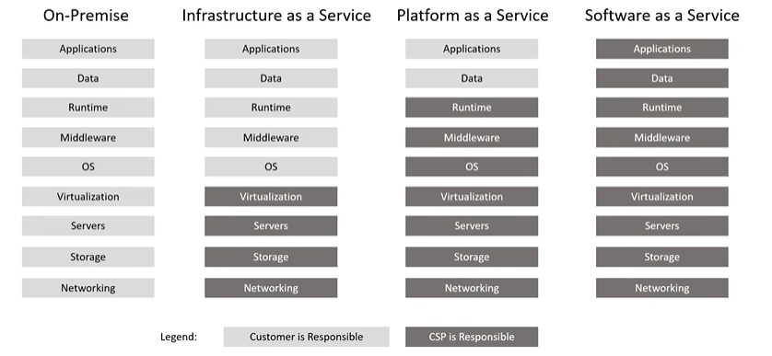

Shared Responsibility Model- Compute:

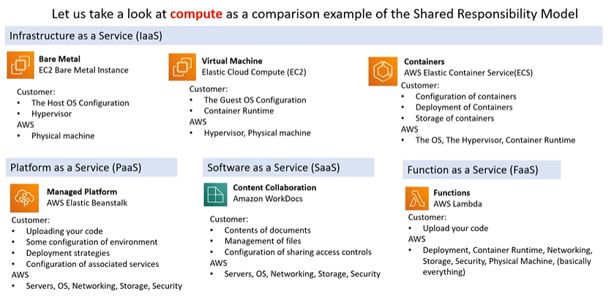 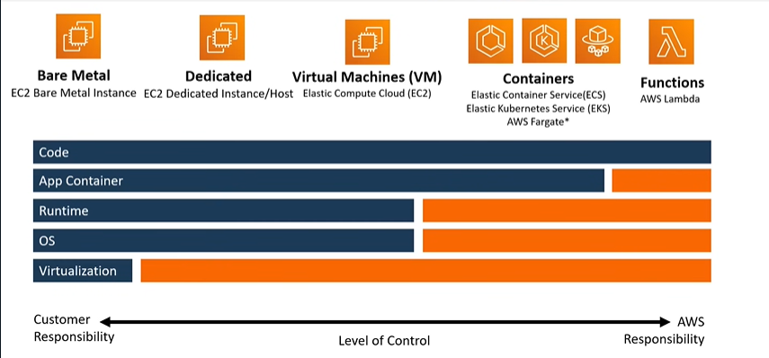

Let’s first take a look at what exactly are these above services:

* + - 1. **AWS EC2 Bare Metal Service**: Amazon EC2 Bare Metal instances provide direct access to physical servers, allowing you to run applications that benefit from high-performance, low-latency access to the underlying hardware. Unlike traditional virtualized instances, these instances run directly on the bare metal hardware, offering the flexibility of the cloud with the control and performance of dedicated servers. **You can think of these instances as your own personal laptops, both run directly on the underlying hardware without the additional layer of virtualization. Applications on the bare metal instances interact directly with the hardware resource of the phyical server.**
      2. **AWS EC2 Virtual Machine**: Amazon EC2 (Elastic Compute Cloud) virtual machines are instances in the cloud that provide scalable computing capacity. They function like virtualized servers, allowing you to run applications, host websites, or perform various computing tasks. EC2 instances are part of the Amazon Web Services (AWS) infrastructure and can be easily scaled up or down based on your needs. Each instance comes with its own operating system and can be configured with different computing resources, such as CPU, memory, and storage, to suit specific requirements.
      3. **AWS Elastic Container Service(ECS)**:

What is a container?

A container is an isolated environment for your code. This means that a container has no knowledge of your operating system, or your files. Containers have everything that your code needs in order to run, down to a base operating system.

AWS Elastic Container Service (ECS) is a fully managed container orchestration service provided by Amazon Web Services (AWS). It enables you to easily run, stop, and manage Docker containers on a cluster. ECS eliminates the need for you to install, operate, and scale your own container orchestration infrastructure.

With ECS, you can deploy and manage containerized applications effortlessly, benefiting from features like automatic scaling, load balancing, and integration with other AWS services.

In summary, AWS ECS simplifies the deployment and management of containerized applications on the AWS cloud infrastructure. 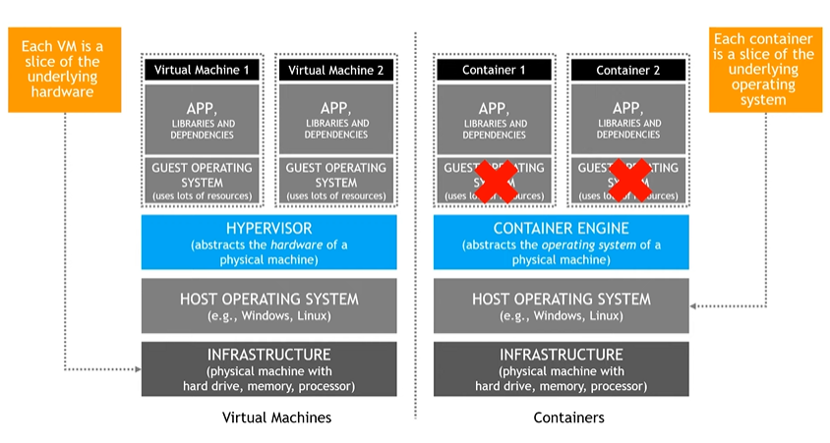 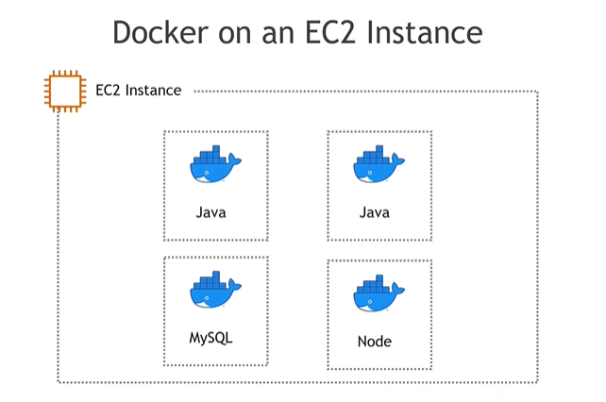 Kubernetes primarily relies on container runtimes to create and manage containers, and Docker is one of the most commonly used container runtimes with Kubernetes.

Here's a simplified overview of how it works:

**1. Container Image Creation:** Developers create container images using tools like Docker. These images contain the application code, dependencies, and runtime environment needed to run the application.

**2. Container Registry:** The created container images are then stored in a container registry (like Docker Hub or AWS ECR). Kubernetes will pull these images from the registry when deploying applications.

**3. Kubernetes Pods:** In Kubernetes, the smallest deployable unit is a pod. A pod represents a group of one or more containers that share the same network namespace and storage. Containers within a pod can communicate with each other using localhost.

**4. Container Runtimes:** Kubernetes supports various container runtimes, and Docker is one of them. When you deploy a pod with containers, Kubernetes interacts with the chosen container runtime (e.g., Docker) to create and manage those containers.

**5. Container Orchestration:** Kubernetes orchestrates the deployment and scaling of these pods across a cluster of machines. It ensures the desired state (as specified in the deployment configuration) is maintained, automatically handling tasks like scaling, load balancing, and self-healing.

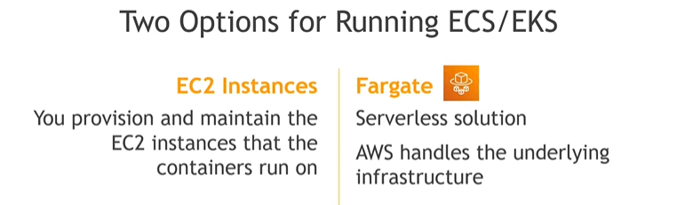

* + - 1. **AWS Lambda:**
* ~~Serverless computing~~ ?
* Runs on a server you don’t have to buy or manage.
* Code runs on a server you don’t have buy of manage.
* Code runs in reponse to some event, on a server you don’t have to buy or manage.
* It can also be thought as a function or script.

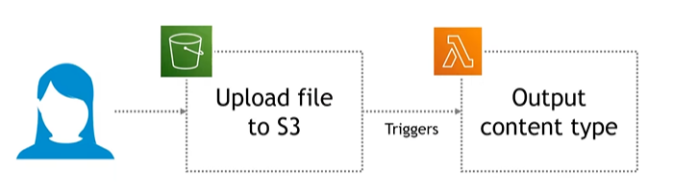

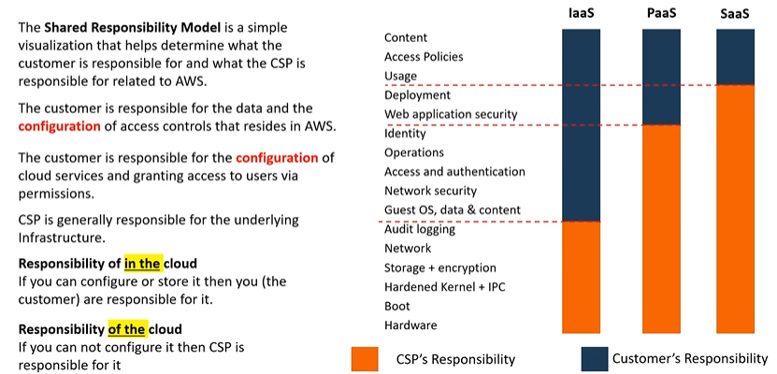 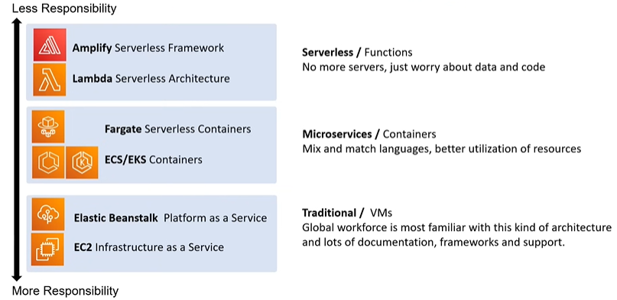Computing Service: 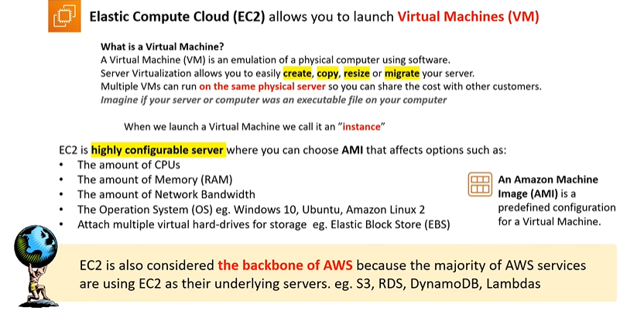

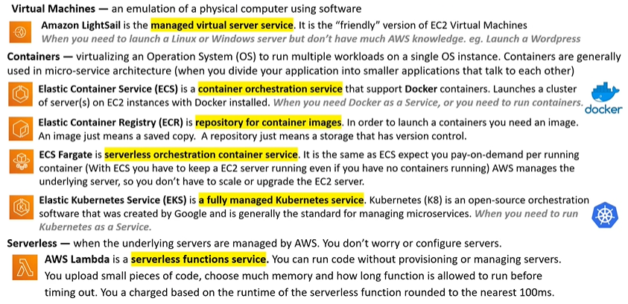

Higher Performance Computing: 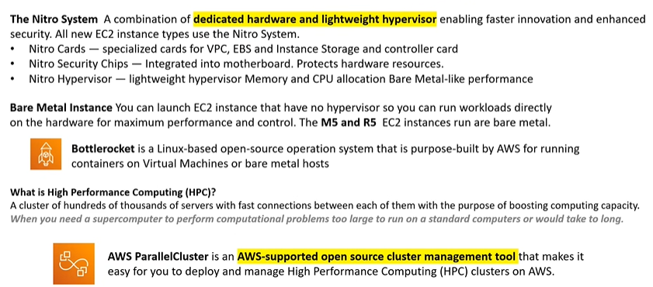

**(Bottle Rocket has its own Contrainer Run Time called containerd, just like Docker)**

**What are AWS Nitro Systems ?**

**AWS Nitro System** is a combination of hardware and software components designed by Amazon Web Services (AWS) to enhance the performance, security, and manageability of their EC2 (Elastic Compute Cloud) instances. Here's a breakdown:

**1. Hardware Components:**

**Nitro Cards**: These are custom-built, purpose-specific hardware cards installed on each physical server. They offload various traditional virtualization functions such as handling network and storage I/O, managing memory and secure access controls, from the main server's CPU to improve efficiency.

**Nitro Security Chip:** This is a dedicated hardware component that provides a secure environment for protecting and managing access to the Nitro System, enhancing the overall security of EC2 instances.

**2. Software Components:**

**Nitro Hypervisor**: It's a lightweight, bare-metal hypervisor designed for high performance. It allows for efficient isolation of multiple instances on a single physical server.

**Nitro Security Module (NSM):** This software component handles security-related functions, such as cryptographic key management and monitoring for security events.

**Nitro Controller**: This is responsible for managing the hardware components and communicating with the Nitro Cards and Nitro Security Chip.

In summary, the AWS Nitro System is a set of hardware and software components that work together to optimize the performance, security, and manageability of EC2 instances, ultimately enhancing the overall efficiency and flexibility of AWS cloud services.

Edge and Hybrid computing Services:

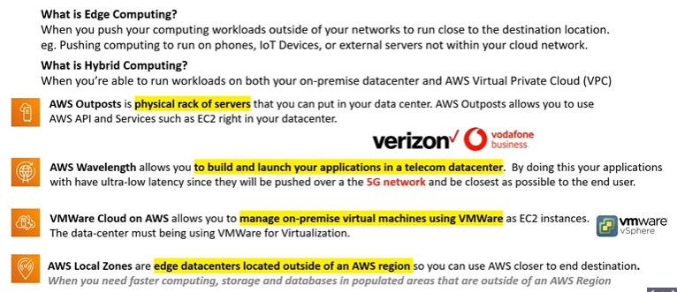

Cost and Capacity Management Computing Services:

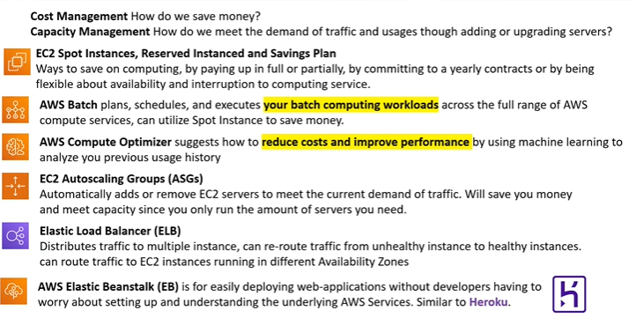

**On-Demand Instances** are ideal for short-term, irregular workloads that cannot be interrupted. No upfront costs or minimum contracts apply. The instances run continuously until you stop them, and you pay for only the compute time you use.

Sample use cases for On-Demand Instances include developing and testing applications and running applications that have unpredictable usage patterns. On-Demand Instances are not recommended for workloads that last a year or longer because these workloads can experience greater cost savings using Reserved Instances.

**Reserved Instances** are a billing discount applied to the use of On-Demand Instances in your account. There are two available types of Reserved Instances:

* **Standard Reserved Instances**
* **Convertible Reserved Instances**

You can purchase Standard Reserved and Convertible Reserved Instances for a 1-year or 3-year term. You realize greater cost savings with the 3-year option.

**Standard Reserved Instances**: This option is a good fit if you know the EC2 instance type and size you need for your steady-state applications and in which AWS Region you plan to run them. Reserved Instances require you to state the following qualifications:

Instance type and size: For example, m5.xlarge

Platform description (operating system): For example, Microsoft Windows Server or Red Hat Enterprise Linux

Tenancy: Default tenancy or dedicated tenancy

You have the option to specify an Availability Zone for your EC2 Reserved Instances. If you make this specification, you get EC2 capacity reservation. This ensures that your desired amount of EC2 instances will be available when you need them.

**Convertible Reserved Instances:** If you need to run your EC2 instances in different Availability Zones or different instance types, then Convertible Reserved Instances might be right for you. Note: You trade in a deeper discount when you require flexibility to run your EC2 instances.

At the end of a Reserved Instance term, you can continue using the Amazon EC2 instance without interruption. However, you are charged On-Demand rates until you do one of the following:

Terminate the instance.

Purchase a new Reserved Instance that matches the instance attributes (instance family and size, Region, platform, and tenancy).

**AWS offers Savings Plans** for a few compute services, including Amazon EC2. EC2 Instance Savings Plans reduce your EC2 instance costs when you make an hourly spend commitment to an instance family and Region for a 1-year or 3-year term. This term commitment results in savings of up to 72 percent compared to On-Demand rates. Any usage up to the commitment is charged at the discounted Savings Plans rate (for example, $10 per hour). Any usage beyond the commitment is charged at regular On-Demand rates.

The EC2 Instance Savings Plans are a good option if you need flexibility in your Amazon EC2 usage over the duration of the commitment term. You have the benefit of saving costs on running any EC2 instance within an EC2 instance family in a chosen Region (for example, M5 usage in N. Virginia) regardless of Availability Zone, instance size, OS, or tenancy. The savings with EC2 Instance Savings Plans are similar to the savings provided by Standard Reserved Instances.

Unlike Reserved Instances, however, you don't need to specify up front what EC2 instance type and size (for example, m5.xlarge), OS, and tenancy to get a discount. Further, you don't need to commit to a certain number of EC2 instances over a 1-year or 3-year term. Additionally, the EC2 Instance Savings Plans don't include an EC2 capacity reservation option.

**Savings Plans enable you to achieve cost savings by committing to a consistent amount of compute usage, measured in dollars per hour, for a 1 or 3-year term. On the other hand, Reserved Instances offer cost savings by committing to a specific instance type in a region and optionally an availability zone, ensuring reserved capacity for that instance type for the chosen 1 or 3-year term.**

**Spot Instances** are ideal for workloads with flexible start and end times, or that can withstand interruptions. Spot Instances use unused Amazon EC2 computing capacity and offer you cost savings at up to 90% off of On-Demand prices.

Suppose that you have a background processing job that can start and stop as needed (such as the data processing job for a customer survey). You want to start and stop the processing job without affecting the overall operations of your business. If you make a Spot request and Amazon EC2 capacity is available, your Spot Instance launches. However, if you make a Spot request and Amazon EC2 capacity is unavailable, the request is not successful until capacity becomes available. The unavailable capacity might delay the launch of your background processing job.

After you have launched a Spot Instance, if capacity is no longer available or demand for Spot Instances increases, your instance may be interrupted. This might not pose any issues for your background processing job. However, in the earlier example of developing and testing applications, you would most likely want to avoid unexpected interruptions. Therefore, choose a different EC2 instance type that is ideal for those tasks.

**Dedicated Hosts** are physical servers with Amazon EC2 instance capacity that is fully dedicated to your use.

You can use your existing per-socket, per-core, or per-VM software licenses to help maintain license compliance. You can purchase On-Demand Dedicated Hosts and Dedicated Hosts

Types of Storage Services:

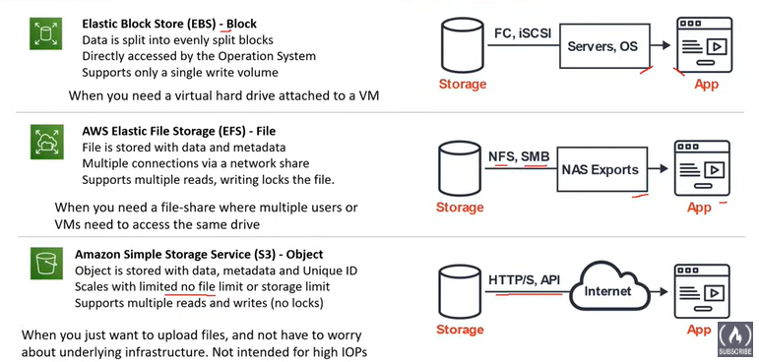

Block stores are virtual hard drives for EC2.

Introduction to S3:

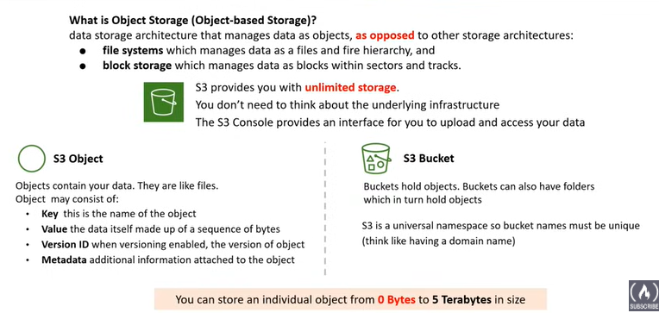

S3 Storage Class:

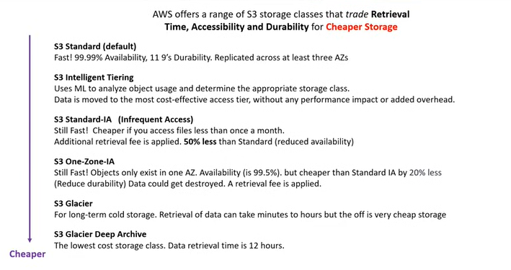

AWS SNOW Family:

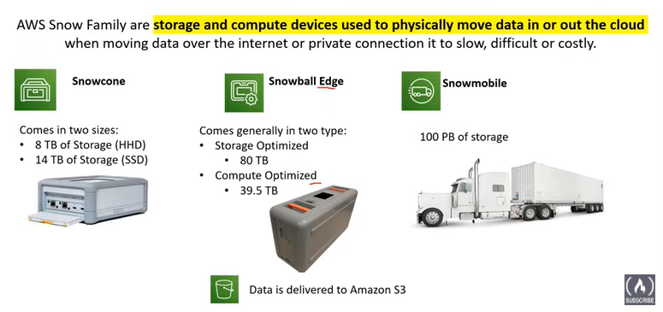

The AWS Snow Family is a set of physical devices designed to help organizations with large data transfer and data migration challenges, particularly when dealing with significant volumes of data that may not be easily or efficiently transferred over the internet.

AWS Snow Family includes several devices:

**1. AWS Snowcone:** A small, rugged, and portable edge computing and data transfer device. It is designed for use in harsh environments and can be carried in a backpack. Snowcone is suitable for scenarios like IoT, tactical edge computing, and disconnected environments.

**2. AWS Snowball:** A larger device designed for data migration and large-scale data transfer. Snowball comes in two variants: Snowball Edge Storage Optimized and Snowball Edge Compute Optimized. It includes onboard compute capabilities for edge computing use cases.

* **Snowball Edge Storage Optimized:** This variant is optimized for high capacity storage. E.g Data collection in remote location , video capture at events or archival of large data sets.
* **Snowball Edge Compute Optimized:** This variant balances storage and computational capabilities. It includes an onboard EC2 Computing capability allowing you to run AWS Lambda functions, Amazon EC2 Instances or AWS IoT Greengrass locally on device. E.g. Data , where you need to perform local processing or analysis of data before transfering it to AWS.

The computation is done locally as these devices are made for rough situations where very low to no internet access is present.

**3. AWS Snowmobile:** An exabyte-scale data transfer solution. Snowmobile is a secure, ruggedized shipping container that can transfer up to 100 PB of data to AWS. It is suitable for massive data migration projects.

These physical devices are shipped to your location, where you can load your data onto them. After loading the data, the devices are then shipped back to AWS for data transfer into the AWS Cloud.

Storage Services:

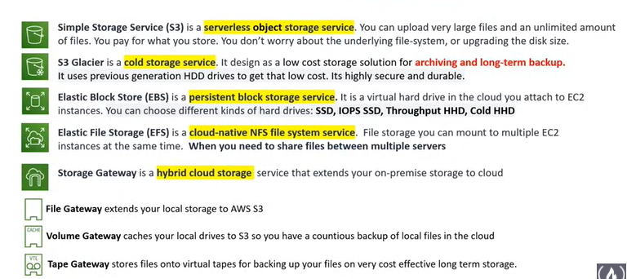

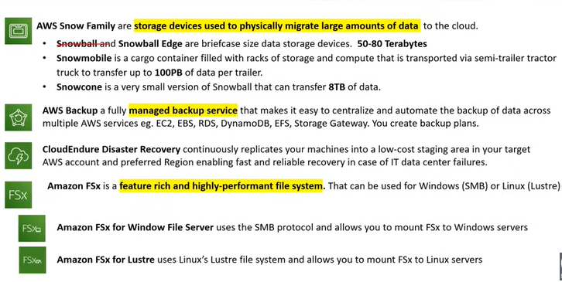

What is a Database?

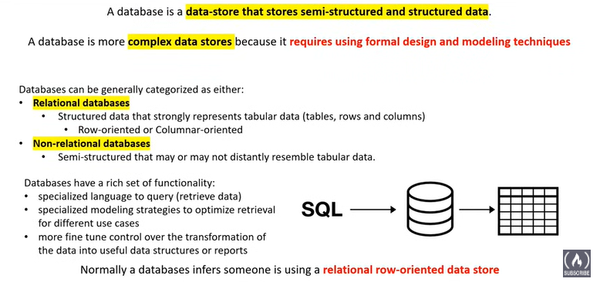

What is Data Warehouse ?

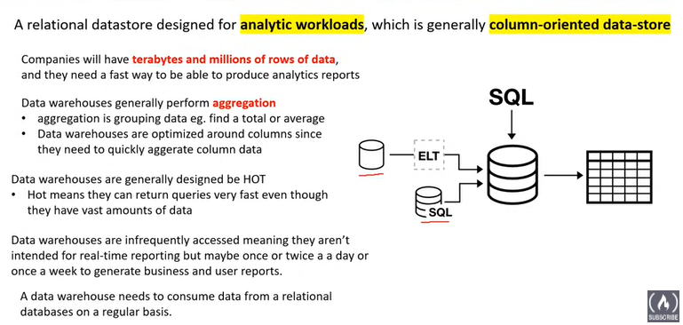

**A data warehouse** is a centralized repository that integrates data from various sources within an organization to support business intelligence and decision-making processes. It is designed for efficient querying and reporting, providing a historical and consolidated view of data for analysis. Key characteristics include:

1. Data Integration: Data warehouses collect and integrate data from disparate sources, such as transactional databases, spreadsheets, and external systems.

2. Subject-Oriented: Data warehouses are organized around key business subjects, like sales, customers, or products, to facilitate analysis in a meaningful context.

3. Time-Variant: They store historical data, allowing for trend analysis and comparison of data over time to identify patterns and make informed decisions.

4. Non-volatile: Data in a warehouse is not frequently updated; it's a snapshot of historical information. This stability ensures consistency for analytical purposes.

Examples of data warehouses include:

- Retail: A retail company might use a data warehouse to analyze sales trends, track inventory levels, and understand customer purchasing behavior.

In essence, a data warehouse provides a structured and optimized environment for businesses to gain insights, make informed decisions, and derive value from their data.

What is a Key Value store ?

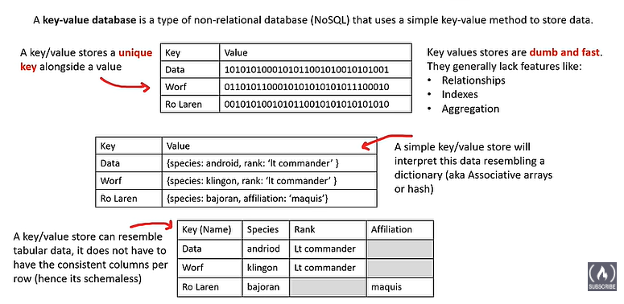

A key-value store is a type of database that stores data as a collection of key-value pairs, much like a dictionary. Each key is a unique identifier that maps to a single value. The values can be simple data types like strings and numbers, or more complex objects like JSON or serialized objects.

What is a Document Database?

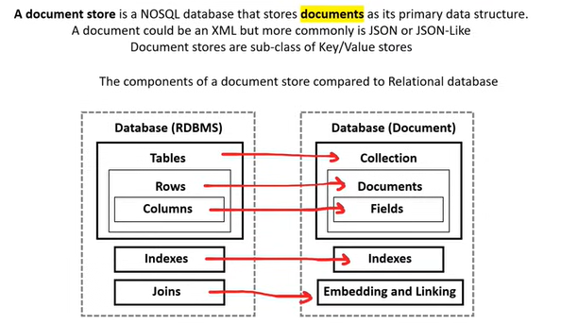

A document store, also known as a document-oriented database or simply a document database, is a type of NoSQL database that stores and organizes data in a semi-structured format called documents. Unlike traditional relational databases, which store data in tables with predefined schemas, document stores allow for more flexible and dynamic data structures.

In a document store, data is typically stored in JSON (JavaScript Object Notation) or similar formats, such as BSON (Binary JSON). Each document contains key-value pairs and may include nested structures, arrays, and other complex data types. Documents within the same collection (similar to a table in relational databases) can have different fields, allowing for schema flexibility.

No SQL Database Services: 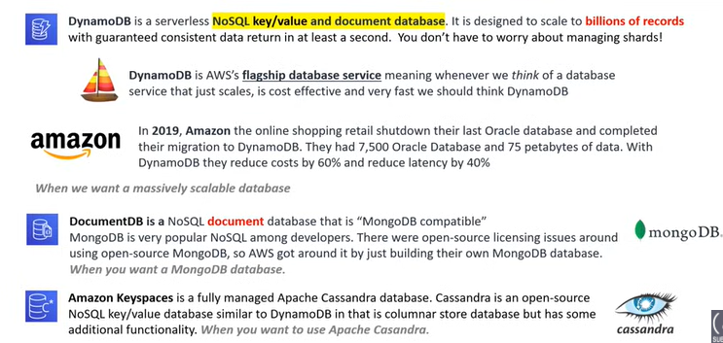

While all three services—Amazon DynamoDB, Amazon DocumentDB, and Amazon Keyspaces—are categorized as NoSQL databases, they differ in terms of their underlying data models and compatibility with existing database systems.

1. Amazon DynamoDB:

* Data Model: Key-value and document-oriented.
* Compatibility: Not tied to a specific existing database system. It has its own data model and API.
* Use Cases: Suited for a variety of applications requiring key-value or document-oriented storage.

2. Amazon DocumentDB (with MongoDB compatibility):

* Data Model: Document-oriented, compatible with MongoDB's BSON (Binary JSON) documents.
* Compatibility: Specifically designed to be compatible with MongoDB, allowing users to migrate MongoDB applications easily.
* Use Cases: Ideal for applications that leverage the document data model and want to transition from MongoDB to a managed service.

3. Amazon Keyspaces (for Apache Cassandra):

* Data Model: Wide-column store data model, compatible with Apache Cassandra.
* Compatibility: Designed to be compatible with Apache Cassandra, providing users with a managed Cassandra service.
* Use Cases: Suited for applications requiring the flexibility and scalability of a wide-column store data model, with compatibility for Apache Cassandra.

In summary, DynamoDB is a general-purpose NoSQL database, DocumentDB is tailored for MongoDB compatibility, and Keyspaces is designed to be compatible with Apache Cassandra. The choice among them depends on your specific use case, data model preferences, and any existing technology stack considerations.

Relational Database Services:

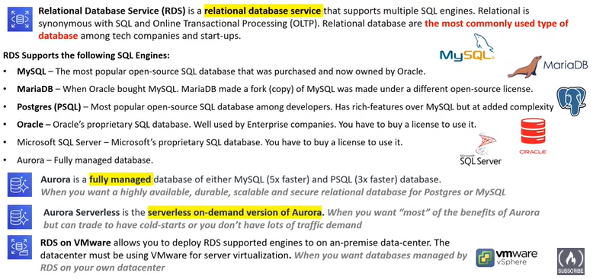

Other Database Services:

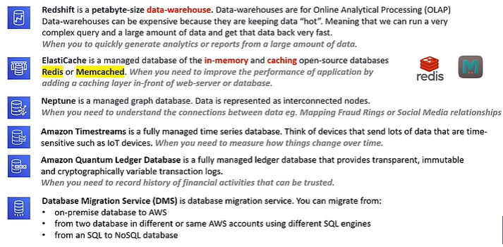

**Timestream** is specifically designed to efficiently store and analyze time-series data, which is data that's captured over time in a sequence of timestamped values.

**AWS Quantum Ledger Database (QLDB)** offers a centralized, transparent, and immutable record of all transactions.Every change to data is permanently recorded in an append-only journal, ensuring data integrity and auditability.QLDB uses cryptography to guarantee data authenticity and prevent tampering. It maintains a complete history of data changes, allowing you to trace back and reconstruct events.

* Financial ledgers: Track financial transactions, account balances, and regulatory compliance.
* Medical records: Securely store and manage patient health records with complete audit trails

Cloud Native Networking Services:

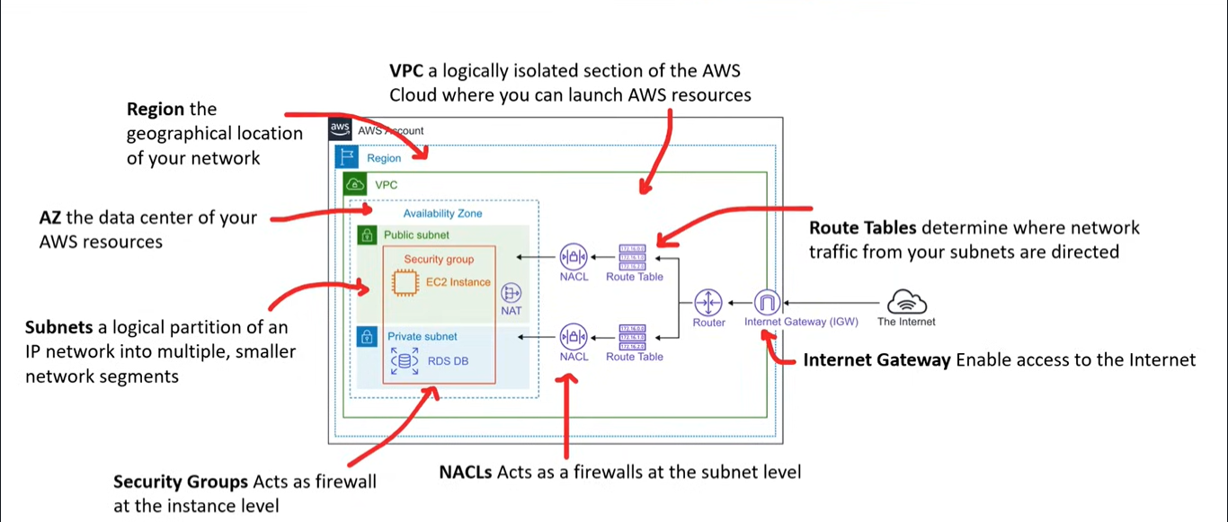

Enterprise/Hybrid Networking Services:

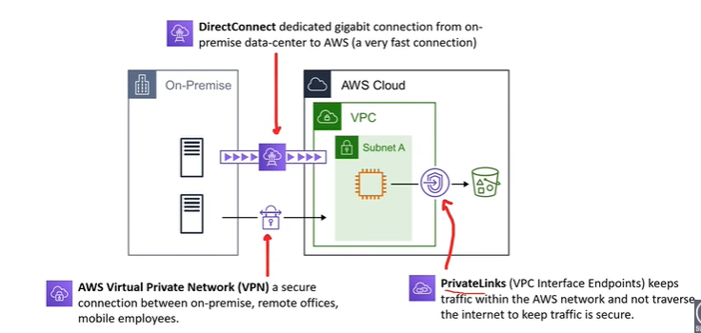

Virtual Private Cloud and Subnets:

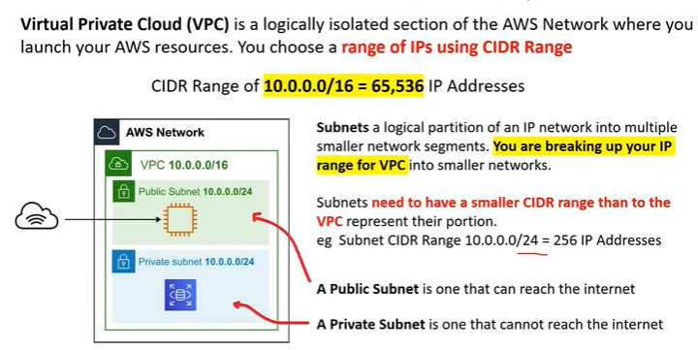

**An Amazon Virtual Private Cloud (VPC)** is a logically isolated virtual network in the AWS cloud where you can launch your AWS resources in a virtual network that you define. You have complete control over your virtual networking environment, including the selection of your own IP address ranges, creation of subnets, and configuration of route tables and network gateways. Think of it as your own private network within the larger AWS cloud.

**CIDR** range might look like 192.168.0.0/24. Here, 192.168.0.0 is the IP address, and /24 indicates that the first 24 bits of the IP address represent the network portion. The remaining 8 bits are available for host addresses within that network.

CIDR ranges are commonly used in networking and are particularly relevant when setting up subnets within a Virtual Private Cloud (VPC) in AWS or other networking environments.

A **subnet** is a logically divided section of a larger network. In the context of AWS or other cloud services, it's a way to partition a Virtual Private Cloud (VPC) into smaller, more manageable networks. Subnets are created to group and organize resources, and they play a crucial role in defining the structure of a network.

Each subnet has its own IP address range, and resources within a subnet can communicate with each other directly. Subnets also provide a level of isolation and security. In AWS, subnets are typically associated with a specific availability zone within a region, helping to distribute resources across different data centers for improved fault tolerance.

When you create a VPC, you usually create multiple subnets to organize and compartmentalize your resources based on different requirements and security considerations.

Security Groups vs NACLs:

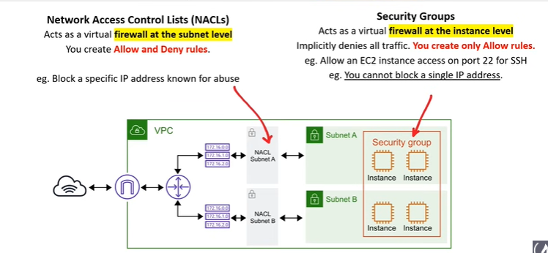

**Network Access Control Lists (NACLs) and Security Groups** are both AWS features that help control inbound and outbound traffic to your resources, but they operate at different levels of the network stack.

1. Security Groups:

- Operate at the instance level (first layer of defense).

- Are stateful, meaning if you allow inbound traffic, the corresponding outbound traffic is automatically allowed.

- Allow rules only to "Allow" traffic; there are no "Deny" rules.

- Automatically apply to instances when you launch them, and you can modify them while instances are running.

2. Network Access Control Lists (NACLs):

- Operate at the subnet level (second layer of defense).

- Are stateless, meaning if you allow inbound traffic, you must separately allow corresponding outbound traffic.

- Allow both "Allow" and "Deny" rules, providing more granular control.

- Are associated with subnets, and you can modify them at any time.

In summary, Security Groups are typically used for allowing or denying traffic at the instance level, while NACLs provide additional control at the subnet level, offering a secondary layer of defense for your network architecture in AWS.

**Examples of both:**

Certainly, let's consider examples for both Security Groups and Network Access Control Lists (NACLs) in AWS:

1. Security Group Example:

- Imagine you have a web server running on an EC2 instance.

- You create a Security Group for this instance that allows inbound traffic on port 80 (HTTP) and port 443 (HTTPS).

- Any external user trying to access the web server is allowed because of the rules in the Security Group.

2. Network Access Control List (NACL) Example:

- Suppose you have multiple subnets within your VPC.

- You create a NACL for one of these subnets that allows inbound traffic only from a specific IP range.

- Any traffic coming into that subnet from the specified IP range is allowed, while traffic from other IP ranges is denied.

In summary, Security Groups control access at the instance level, while NACLs provide an additional layer of control at the subnet level within your AWS VPC.

Introduction to EC2:

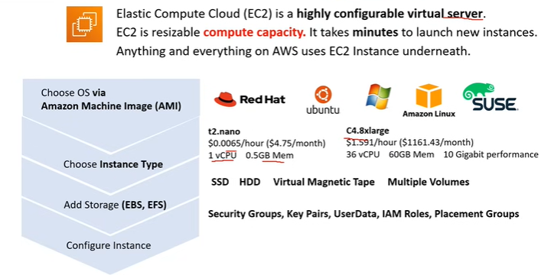

EC2 Instance Families:

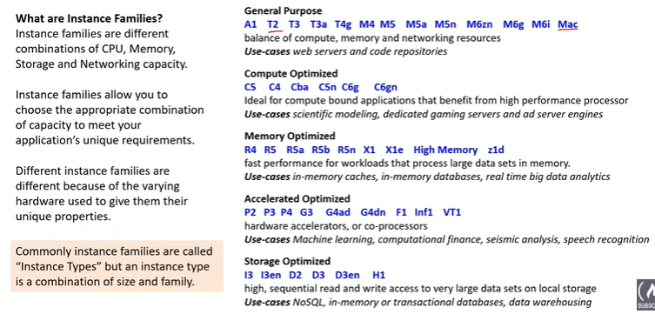

EC2 Instance Types:

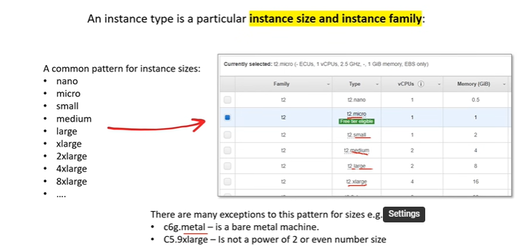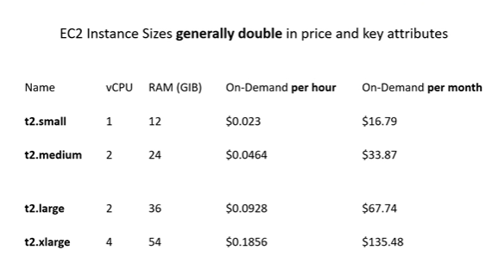

Dedicated Host vs Dedicated Instances:

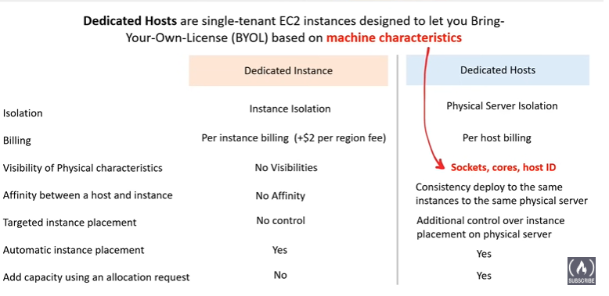 Choosing between Dedicated Hosts and Dedicated Instances on AWS can be tricky, as both offer dedicated physical servers for your workloads. But the key differences lie in the level of control, visibility, and pricing:

**Dedicated Hosts:**

* Control and Visibility: You get full control over the entire physical server, including CPU, RAM, storage, and network configuration. You have deep insights into hardware performance and can install custom software or licenses (Bring Your Own License - BYOL). This is ideal for scenarios like:
* Meeting strict compliance requirements: You can tailor the environment to specific security standards.
* Optimizing performance for niche workloads: You can fine-tune the server for specific applications.
* Running specialized software licenses: BYOL licenses like Windows Server or SQL Server require dedicated hosts.

**Dedicated Instances:**

* Simple Isolation: You reserve a specific instance type on a dedicated physical server, but with less control than Dedicated Hosts. You can't choose the underlying hardware or install custom software, but still benefit from:
* Improved Security and Predictability: No noisy neighbors from other accounts, ensuring consistent performance and resource availability.
* Compliance Support: Can help meet some compliance requirements, though not as granular as Dedicated Hosts.

Which to Choose?

Here's a quick guide:

**Choose Dedicated Hosts if:**

1. You need full control and visibility over the physical server.
2. You have BYOL licenses that require dedicated hardware.
3. You have performance-critical workloads with specific hardware requirements.

Choose Dedicated Instances if:

* You simply want to isolate your workloads from other AWS accounts.
* You need basic resource guarantees and improved security compared to shared tenancy.
* You value cost-effectiveness over fine-grained control.

EC2 Tenancy:

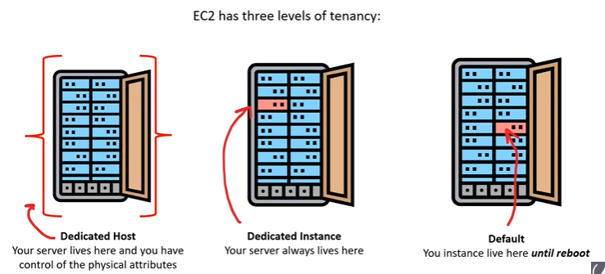

Elastic IP:

In AWS, an Elastic IP is a static, public IPv4 address designed for dynamic cloud computing. It's essentially a dedicated phone number for your instance, separate from the dynamic IP addresses assigned by default. Here's what makes it special:

**Static**: Unlike the default IP that changes when you stop or restart an instance, an Elastic IP remains constant, ensuring consistent reachability for your instance. This is crucial for services like web servers, databases, or applications that need a fixed address for connections.

**Public**: An Elastic IP allows your instance to be directly accessible from the internet, facilitating connections and communication with external resources. This makes it ideal for hosting public-facing applications like websites, APIs, or remote access servers.

**Dynamically Assignable**: You can associate an Elastic IP with any instance or network interface in your VPC, allowing you to quickly migrate it between resources. This helps with:

* High availability: If an instance fails, you can reassign the Elastic IP to a healthy instance, minimizing downtime.
* Load balancing: Distribute traffic across multiple instances using a single Elastic IP.
* Scalability: Easily add or remove instances without changing the address exposed to the outside world.

Additional Benefits:

* DNS integration: You can point your domain name to your Elastic IP, providing a user-friendly address for your service.
* Cost-effective: You only pay for the Elastic IP itself, not for data transfer like with public IP addresses.

Who uses Elastic IPs?

Anyone needing a reliable and consistent way to access their AWS resources benefits from Elastic IPs. Here are some common use cases:

* Web servers and applications
* Databases and application servers
* Remote access servers and VPN gateways
* Load balancers and high availability configurations

**To summarize:**

An Elastic IP is a valuable tool in AWS, offering a static, public IP address for your instances, enabling consistent reachability, dynamic migration, and improved connectivity for various cloud workloads.

Auto Scaling Group:

In AWS, an Auto Scaling Group is a collection of EC2 instances that are managed together to automatically adjust the number of instances up or down based on demand. This helps ensure that you always have the right amount of resources available to handle your workload, without wasting money on unused instances.

Imagine an Auto Scaling Group as a team of workers. When your workload is light, you only need a few workers to get the job done. But when things get busy, you can quickly add more workers to keep up with the demand. And when the workload slows down again, you can send some of the workers home to save on costs.

Here are some key features of Auto Scaling Groups:

* Scaling based on metrics: You can define scaling policies that tell the Auto Scaling Group how to adjust the number of instances based on metrics like CPU utilization, network traffic, or custom application metrics.
* Health checks: Auto Scaling Groups use health checks to monitor the health of your instances. If an instance becomes unhealthy, it will be automatically replaced with a healthy one.
* Load balancing: You can use Auto Scaling Groups with load balancers to distribute traffic across your instances.
* Scheduled scaling: You can schedule Auto Scaling Groups to automatically scale up or down at specific times of the day or week.

EC2 Launch Template:

In Amazon Web Services (AWS), a launch template is a resource that contains the information to launch an EC2 (Elastic Compute Cloud) instance or instances. It allows you to specify the instance type, AMI (Amazon Machine Image), key pair, security groups, block device mappings, and other configuration details. Launch templates provide a convenient way to consistently launch instances with predefined settings.

Here are some key features and components of AWS EC2 launch templates:

1. Configuration Options:

* Instance Type: Specifies the type of EC2 instance you want to launch.
* AMI ID: Identifies the Amazon Machine Image that the instance will be based on.
* Key Pair: Specifies the key pair for SSH access to the instance.
* Security Groups: Defines the security groups that control inbound and outbound traffic to the instance.
* Block Device Mappings: Configures the instance's block devices, including the root volume and additional volumes.

2. Flexibility:

* Launch templates provide a more flexible alternative to EC2 launch configurations, allowing you to use the latest features and options available in EC2.

3. Versioning:

* Launch templates support versioning, allowing you to create and manage different versions with different configurations. This makes it easier to roll back to a previous configuration if needed.

4. Defaults and Overrides:

* You can set default values for most launch template parameters. When launching an instance, you can also override these defaults with specific values.

5. User Data:

* Launch templates allow you to include user data, which is a script that runs when the instance starts. User data can be used for tasks such as installing software or configuring the instance.

6. Instance Market Options:

* You can specify whether instances launched from the template should be On-Demand, Reserved, or Spot Instances. Spot Instances are available at a potentially lower cost but can be terminated if the spot price exceeds your bid.

To create a launch template in the AWS Management Console:

* Open the Amazon EC2 console.
* In the navigation pane, choose "Launch Templates."
* Choose "Create launch template."
* Configure the launch template settings.
* Choose "Create launch template."

After creating a launch template, you can use it to launch EC2 instances through the console, AWS CLI, or SDKs.

Launch templates simplify the process of launching instances with consistent configurations and are particularly useful when managing fleets of instances in an AWS environment.

EC2 AMI (Amazon Machine Image):

An AMI (Amazon Machine Image) is a pre-configured virtual machine image used to create EC2 instances (virtual servers) within the Amazon Web Services (AWS) environment. It provides the necessary information to launch an instance, including the operating system, application server, and applications. Essentially, an AMI is a template for creating virtual machines in the cloud.

**Key characteristics of an AMI include:**

1. Operating System: The AMI contains a specific operating system, such as Amazon Linux, Ubuntu, Microsoft Windows Server, or others. Users can choose an AMI based on their preferred operating system and version.

2. Software Configuration: AMIs may include additional software and configurations beyond the base operating system. This can include pre-installed applications, libraries, and settings tailored for specific use cases.

3. Instance Store or EBS-Backed: An AMI can be either instance store-backed or EBS (Elastic Block Store)-backed. Instance store-backed AMIs use instance store volumes for the root device, while EBS-backed AMIs use EBS volumes, providing more flexibility and durability.

4. Public and Private AMIs: AWS offers a variety of publicly available AMIs that users can use as a starting point. Users can also create and share their custom AMIs, making it easier to replicate specific configurations.

5. Customization and Snapshots: Users can customize an instance launched from an AMI and then create a new AMI based on the modified instance. Additionally, users can create Amazon EBS snapshots of the root device volume, allowing for backup and cloning.

6. AMI ID: Each AMI is identified by a unique AMI ID. Users can refer to this ID when launching EC2 instances to specify the desired AMI.

7. AMI Marketplace: AWS provides a marketplace where third-party vendors can publish and sell their custom AMIs. This allows users to find pre-configured solutions for various applications and services.

Creating an AMI involves capturing a snapshot of a running or stopped EC2 instance. This snapshot includes the root volume, which contains the operating system and any additional configurations. Once an AMI is created, it can be used to launch new instances with the same configuration.

AMIs play a crucial role in the scalability, flexibility, and repeatability of AWS infrastructure, as they enable users to quickly and consistently deploy instances with specific software configurations.

Difference Between AMI and Launch Template:

Amazon Machine Image (AMI) and Launch Template are both components used in Amazon Elastic Compute Cloud (EC2), but they serve different purposes and are part of different stages in the process of creating and launching instances.

**AMI (Amazon Machine Image):**

1. Purpose:

* An AMI is a template for the root file system of an EC2 instance.
* It includes the operating system, applications, libraries, and configurations needed to launch an instance.

2. Contents:

* An AMI contains a snapshot of the root volume (either instance store or EBS-backed) and is essentially a packaged image of a specific state of an EC2 instance.

3. Creation:

* AMIs are created by taking a snapshot of a running or stopped EC2 instance.
* Users can create custom AMIs based on their requirements.

4. Usage:

* AMIs are used to launch new EC2 instances with the same configuration.
* They serve as a baseline for creating multiple instances with consistent settings.

5. Customization:

* Users can customize instances launched from an AMI, but the AMI itself remains unchanged.

6. Identification:

* Each AMI is identified by a unique AMI ID.

**Launch Template:**

1. Purpose:

* A Launch Template is a mechanism for specifying the configuration details when launching EC2 instances.

2. Contents:

* A Launch Template includes settings such as the AMI ID, instance type, key pair, security groups, block device mappings, and other instance launch parameters.

3. Creation:

* Users create Launch Templates to define a set of configurations for launching instances.

4. Usage:

Launch Templates are used to consistently launch instances with predefined settings.

- They allow users to specify default values and version their launch configurations.

5. Flexibility:

* Launch Templates provide flexibility and can be used to launch instances with the latest features and options available in EC2.

6. Versioning:

* Launch Templates support versioning, allowing users to create and manage different versions with different configurations.

Summary:

In summary, while an AMI is a template for the root file system of an EC2 instance, capturing the entire state of the instance, a Launch Template is a mechanism for defining and versioning the configurations used when launching instances, including details like the AMI ID. Launch Templates are a higher-level abstraction that allows users to consistently launch instances with specific settings, and they often reference one or more AMIs for the base configurations.

Load Balancers:

**Load Balancer** is a service that automatically distributes incoming application traffic across multiple targets, such as Amazon EC2 instances, containers, and IP addresses, to ensure that no single target is overwhelmed with too much traffic. Load balancing enhances the availability and fault tolerance of applications by efficiently distributing incoming requests, improving overall performance and scalability.

**Network Load Balancer (NLB):**

1. Layer of Operation:

* Layer 4 (Transport Layer): NLB operates at the transport layer (Layer 4) of the OSI model.

2. Traffic Handling:

* Handles TCP and UDP Traffic: NLB is designed to handle TCP and UDP traffic, making it suitable for protocols that require low-latency and high-throughput, such as gaming or streaming applications.

3. Content Unaware:

* Content-Unaware Routing: NLB routes traffic based on IP protocol data and is content-unaware. It doesn't inspect the content of the data packets.

4. Use Cases:

* Scalable and Low-Latency: NLB is often used for applications that require scalable and low-latency connections, where content-based routing is not necessary.

5. Monitoring Server Health:

* NLB regularly checks if each game server is healthy. If a server has issues or is overwhelmed, NLB stops sending new players to that server until it recovers.

6. Scaling with Auto Scaling:

* If more players join the game, NLB can automatically detect this and add more game servers to handle the increased traffic. This is done using AWS Auto Scaling.

**Application Load Balancer (ALB):**

1. Layer of Operation:

* Layer 7 (Application Layer): ALB operates at the application layer (Layer 7) of the OSI model.

2. Traffic Handling:

* Handles HTTP, HTTPS, and WebSocket: ALB is designed to handle HTTP, HTTPS, and WebSocket traffic, making it suitable for modern web applications with multiple microservices.

3. Content-Aware Routing:

* Content-Aware Routing: ALB is content-aware and can route traffic based on the content of the requests, allowing for sophisticated routing decisions such as path-based and host-based routing.
* **Path-Based Routing**: Uses the URL path to determine where to send the request.
* **Host-Based Routing**: Uses the host (domain) specified in the request to determine where to send the request.

4. Use Cases:

* Web Applications: ALB is commonly used for web applications, APIs, and microservices where content-based routing and flexibility in handling different paths are required.
* Suitable for modern web applications with diverse routing needs.

In essence, NLB is optimized for handling network traffic efficiently at a lower layer, while ALB is tailored for modern web applications that require advanced content-based routing and support for various protocols. The choice between NLB and ALB depends on the specific requirements of your application and the type of traffic it needs to handle.

**Gateway Load Balancer(GLB):**

Think of GWLB as a super traffic cop in your AWS network.

* It guides all incoming traffic through a single checkpoint (the firewall) to keep your applications safe.
* Like a good cop, it distributes traffic equally among all the available firewalls (instances) so nobody gets overloaded.
* If a firewall gets sick, GWLB bypasses it and sends traffic to healthy ones, keeping your apps online.
* You can add or remove firewalls easily, just like calling for backup when things get busy.

Basically, GWLB makes managing your security and keeping your apps running smoothly a breeze!!

**Classic Load Balancer (CLB):**

Classic Load Balancer (CLB) in AWS is one of the load balancing options provided by Amazon Web Services. However, it's important to note that AWS has been encouraging users to use the newer generation load balancers, such as the Application Load Balancer (ALB) or Network Load Balancer (NLB), as they offer more features and improvements over the Classic Load Balancer.

Here are some key features of the Classic Load Balancer:

1. Operates at Both Layers:

* Classic Load Balancer operates at both Layer 7 (Application Layer) and Layer 4 (Transport Layer) of the OSI model.

2. Suitable for Basic Load Balancing:

* CLB is suitable for applications that require basic load balancing and do not require the advanced features offered by ALB or NLB.

3. Routing Decisions:

* It can make routing decisions based on either application-level information (HTTP/HTTPS requests) or network-level information (TCP/UDP protocols).

4. Sticky Sessions:

* CLB supports sticky sessions, which enable the load balancer to bind a user's session to a specific instance.

5. Security Groups:

* It integrates with security groups, providing basic security features.

6. Cross-Zone Load Balancing:

* CLB supports cross-zone load balancing, distributing traffic evenly across instances in different availability zones.

While Classic Load Balancer is still available, AWS recommends using ALB or NLB for new applications or when modifying existing ones. ALB is recommended for applications with HTTP and HTTPS traffic, while NLB is suitable for applications requiring TCP, UDP, or TLS traffic handling with high performance.

Target Groups:

In the context of AWS load balancing, instances (or targets) that you want to include in the load balancing process need to be registered with a target group. The load balancer, such as an Application Load Balancer (ALB) or Network Load Balancer (NLB), then directs traffic to the instances registered in the target group.

Here's a breakdown of the process:

1. Create a Target Group:

* You create a target group, specifying its configuration and health check settings.

2. Register Targets:

* You register instances (EC2 instances, IP addresses, or containers) with the target group. These instances become part of the group and can receive traffic from the load balancer.

3. Configure Health Checks:

* You configure health checks within the target group. The load balancer regularly checks the health of each registered instance based on the health check settings.

4. Load Balancer Routes Traffic:

* The load balancer, whether it's an ALB or NLB, routes incoming traffic to the registered instances based on the rules and settings you've defined.

5. Dynamic Scaling:

* If you have configured Auto Scaling for your instances, instances can be automatically registered or deregistered from the target group as they scale in or out.

In summary, all instances registered with a particular target group become potential targets for the load balancer. The load balancer makes routing decisions based on the health and configuration of the instances within the target group. This mechanism allows for efficient load distribution, high availability, and dynamic scaling of your applications within an Amazon Virtual Private Cloud (VPC).

EC2 Pricing Models:

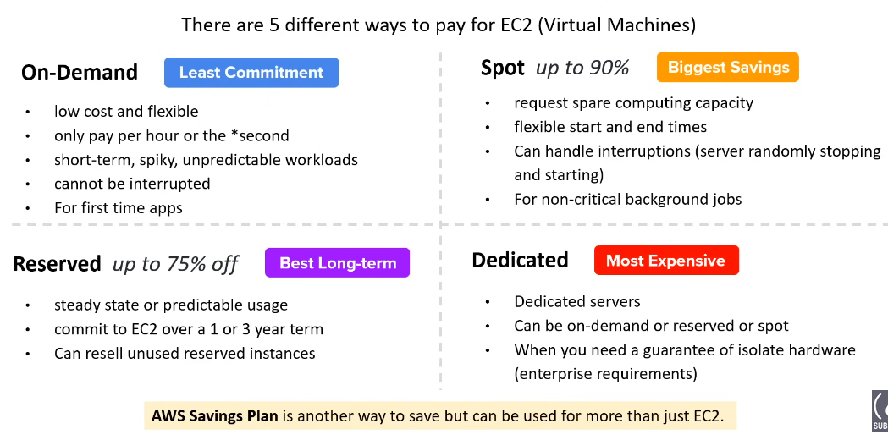

* On Demand:

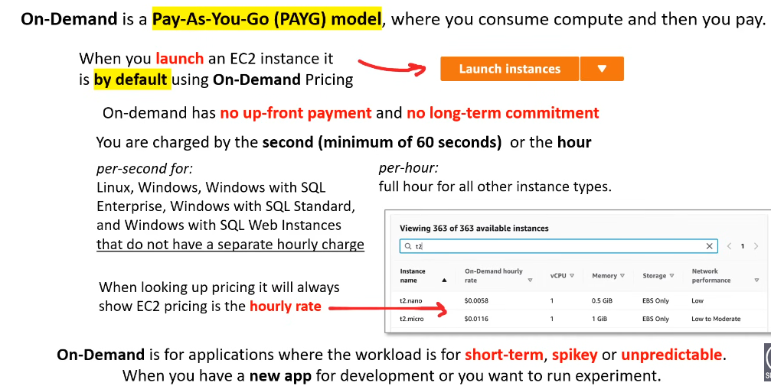

* Reserve Instances:

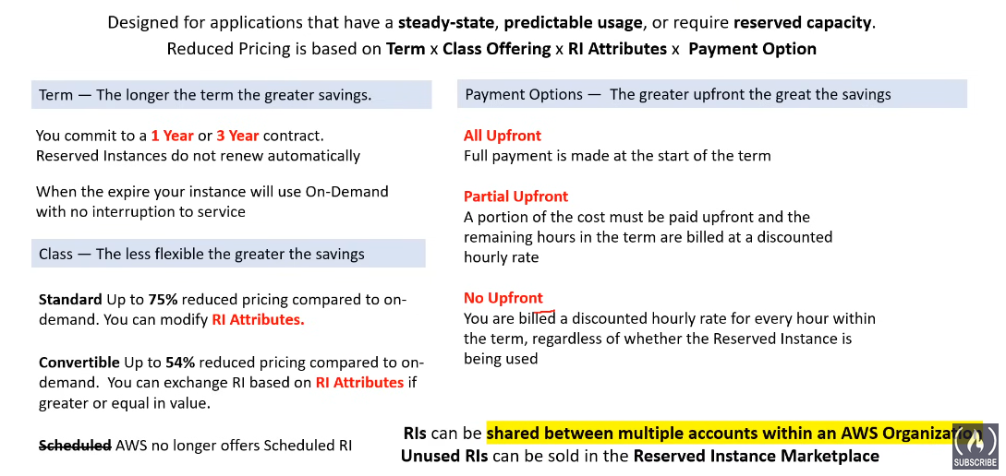

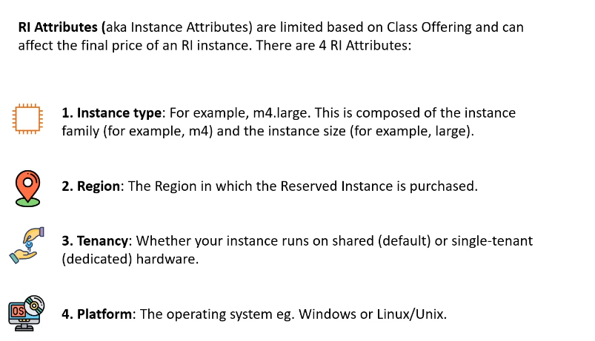

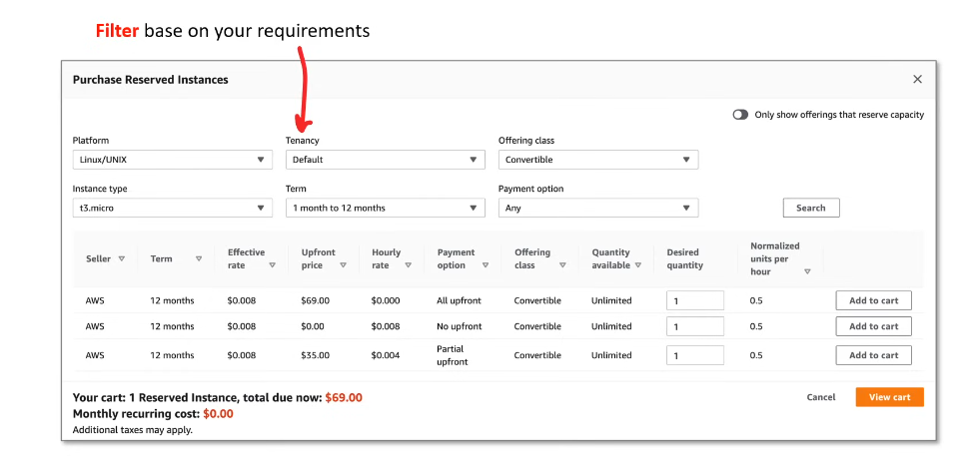

Reserved Instances (RIs) in AWS:

Reserved Instances allow AWS customers to reserve computing capacity for EC2 instances in a specific Availability Zone for a specified term, typically one or three years. This reservation provides a significant discount compared to On-Demand pricing.

#### **Types of Reserved Instances:**

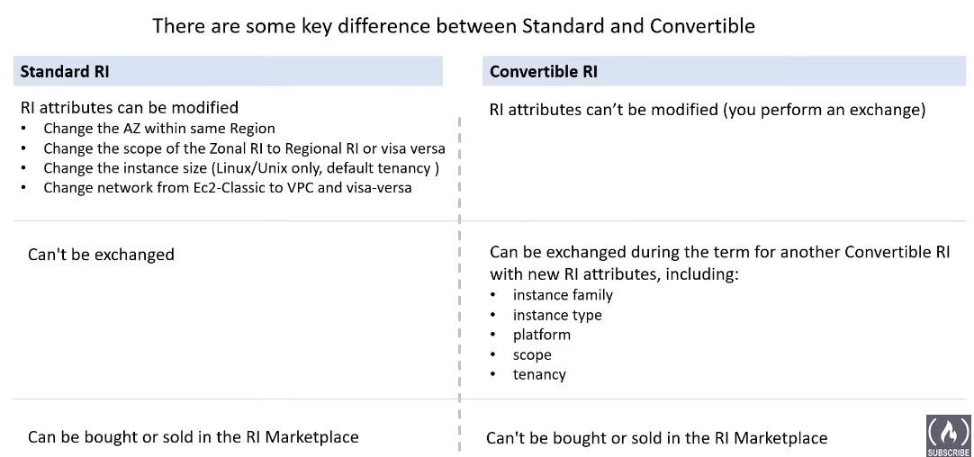

Zonal RI vs Regional RI:

| **Feature** | **Regional Reserved Instances** | **Zonal Reserved Instances** |
| --- | --- | --- |
| **Definition** | Reserved Instances that are not tied to a specific availability zone. They can be used in any availability zone within the same AWS Region. | Reserved Instances that are tied to a specific availability zone. They can only be used in the designated availability zone. |
| **Instance Availability** | Can be launched in any availability zone within the same AWS Region. | Can only be launched in the specific availability zone for which they were purchased. |
| **Flexibility** | Provides more flexibility as it allows instances to be launched in any availability zone within the region, providing a broader scope of usage. | Less flexible, as the reservation is tied to a specific availability zone, limiting the usage to that zone. |
| **Risk Mitigation** | Offers better risk mitigation in case of failure or maintenance events in a specific availability zone. | More susceptible to risk in case of issues affecting the designated availability zone, as the reservation is tied to it. |
| **Availability Zone Changes** | Automatically applies to any availability zone within the region, allowing for easy migration or distribution of instances. | Requires modification or purchase of a new Reserved Instance if you want to change the availability zone. |
| **Instance Launching Across Zones** | Allows launching instances across different availability zones to achieve high availability and fault tolerance. | Limited to launching instances in the designated availability zone, potentially impacting high availability strategies. |
| **Use Case** | Suitable for workloads with high availability requirements and those that need the flexibility to distribute instances across availability zones. | Suitable for workloads that are tied to a specific availability zone and do not require the flexibility to move across zones. |

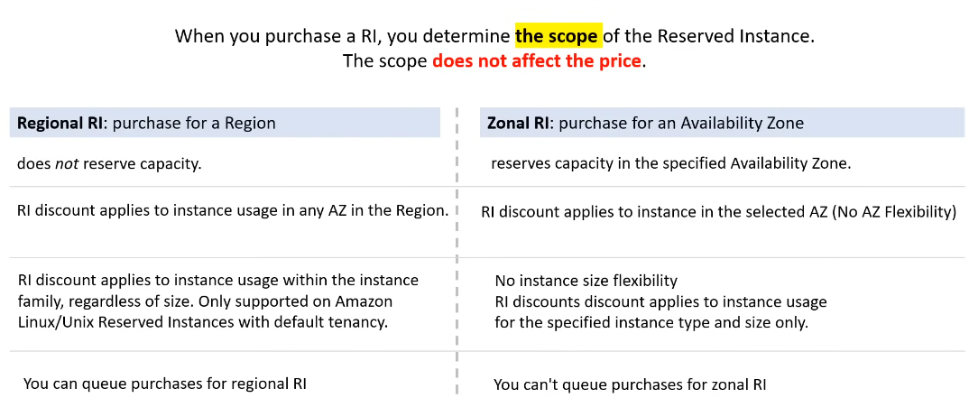

* “Do not reserve capacity" means that Regional Reserved Instances (RIs) do not tie you to a specific set of physical servers (hardware) in a data center.
* With Regional RIs, you can "queue" your purchases. This means that you can buy Reserved Instances for a specific instance type in a region without immediately specifying the availability zone.

RI Limits:

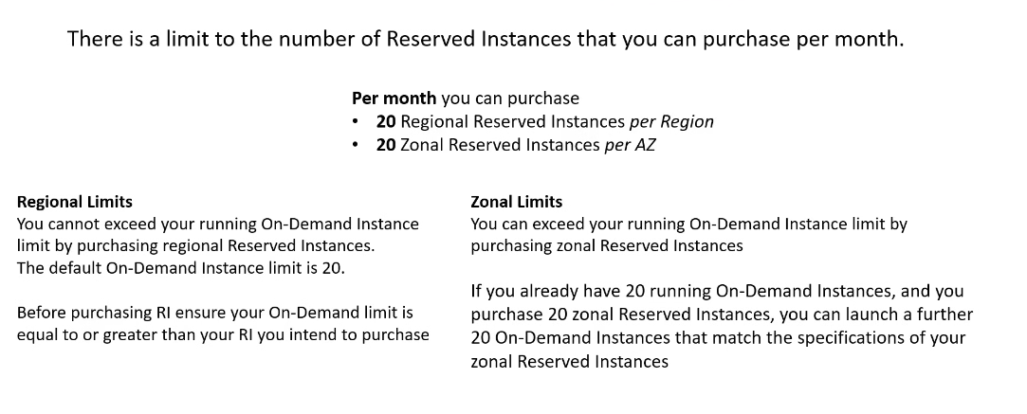

Capacity Reservation:

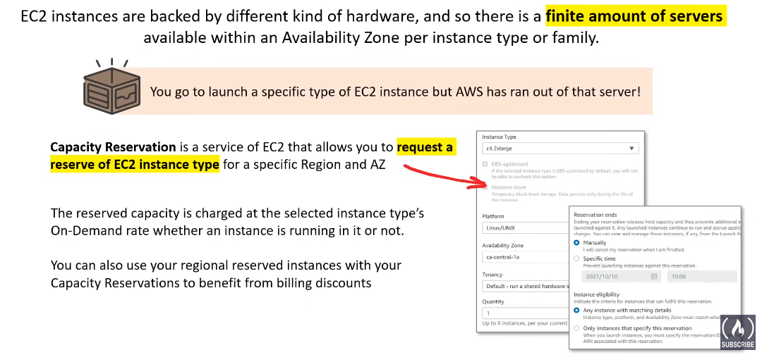

You are billed even if you are not using your reserved capacity.

RI Marketplace:

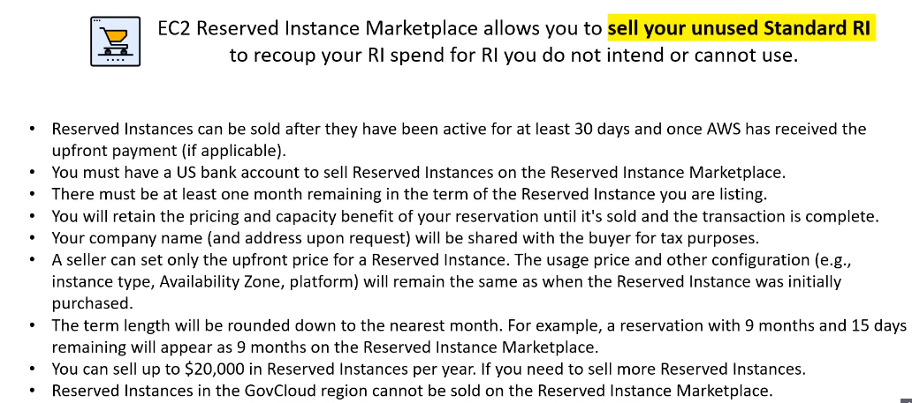

Spot Instances:

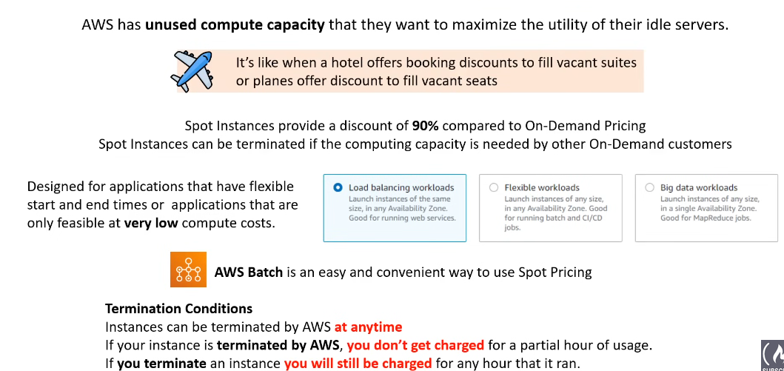

Dedicated Instances:

Dedicated Instances in AWS refer to instances that run on hardware dedicated to a single customer. This means that the physical hardware hosting the dedicated instances is not shared with other AWS customers. **So, with Dedicated Hosts, you get the whole physical server to yourself, and with Dedicated Instances, you have your own special spot in the shared server, which won’t be allocated to any other customer.**

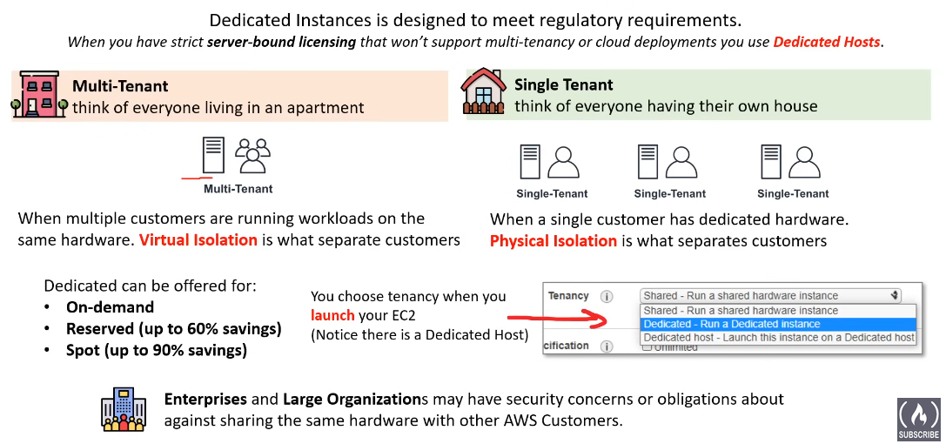

Saving Plan:

**AWS Savings Plans is** a flexible pricing model offered by Amazon Web Services (AWS) that allows customers to achieve significant cost savings on their AWS usage. This model requires a commitment to a consistent amount of compute usage (measured in dollars per hour) for a one or three-year period.

In return for the commitment, AWS offers substantial discounts against On-Demand rates for EC2 instances, AWS Fargate container services, and AWS Lambda serverless computing. The Savings Plans can help you save money on your steady-state usage, reduce costs by modernizing workloads, and centralize and simplify cost management.

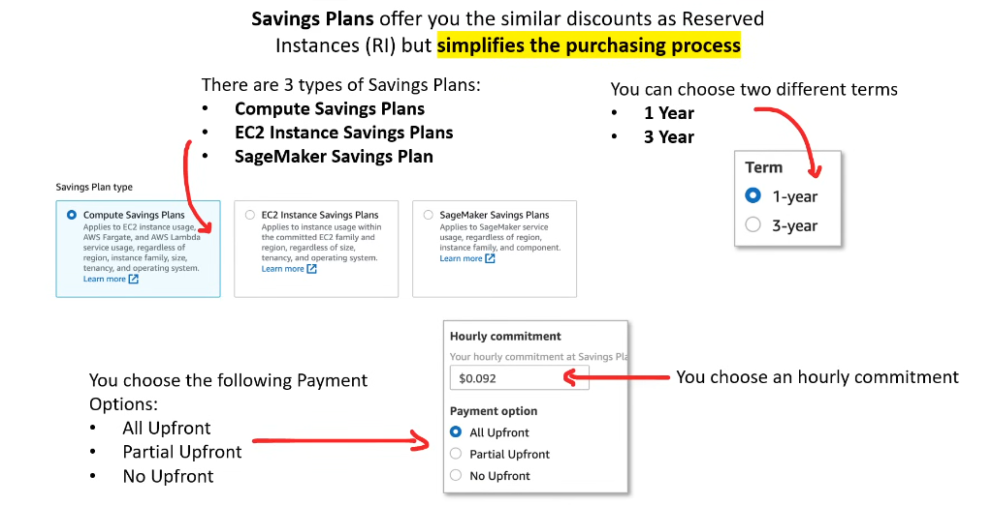

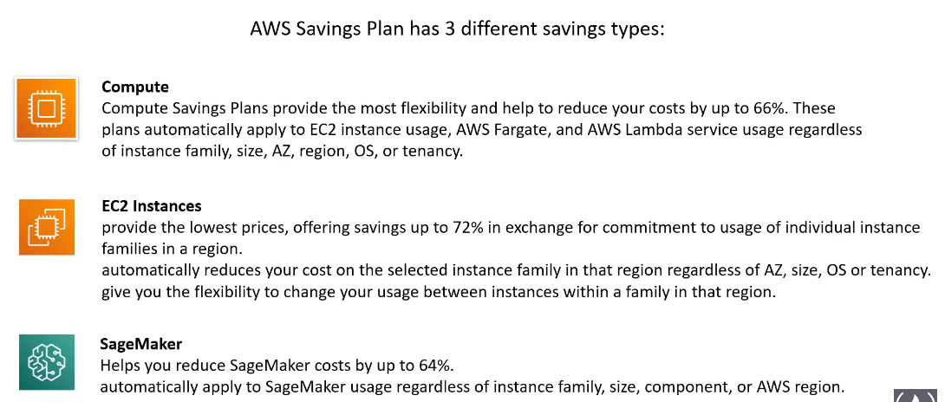

SageMaker service that provides a comprehensive set of tools for building, training, and deploying machine learning models.

Zero Trust Model:

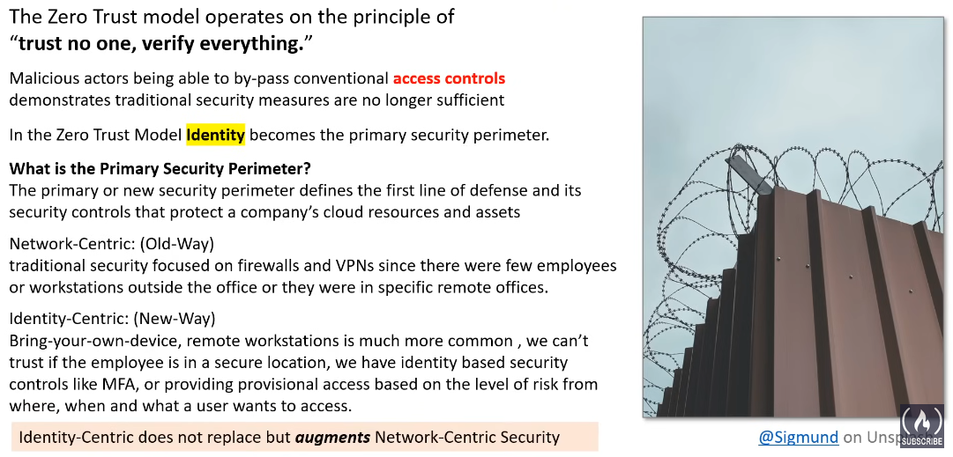

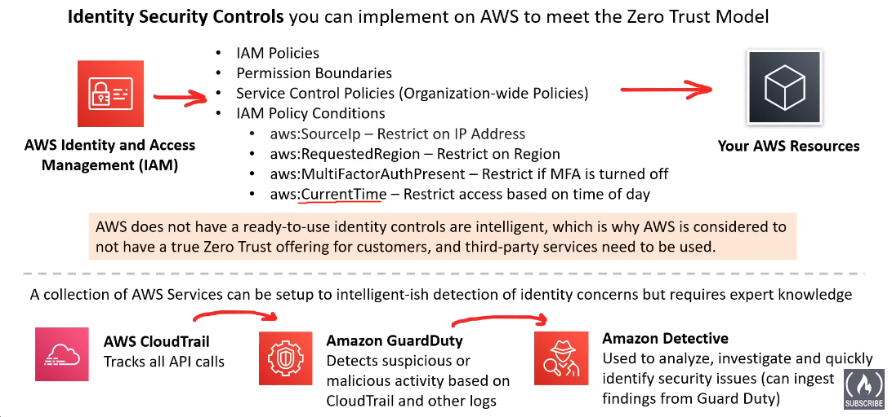

Zero Trust on AWS using Third Parties:

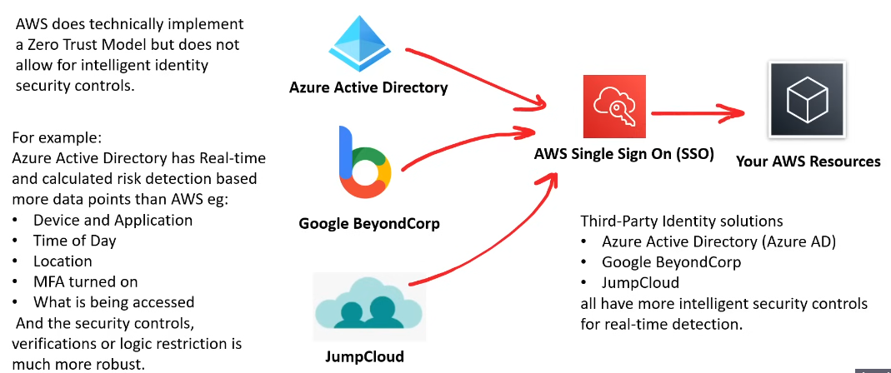

Directory Service:

A directory service is a centralized database or information repository that stores and manages information about network resources, such as users, groups, computers, and other network entities. The primary purpose of a directory service is to provide a single point of access and control for these resources in a networked environment. Directory services play a crucial role in managing user authentication, authorization, and other identity-related tasks.

Here are some key aspects of directory services:

**1. Identity Management:** Directory services store and manage information about users, including their usernames, passwords, email addresses, and group memberships. This information is used for user authentication and authorization across the network.

**2. Access Control:** Directory services enable administrators to control access to resources by defining permissions and policies. Access control lists (ACLs) and group memberships are common mechanisms used to manage permissions within a directory.

**3. Authentication:** Directory services authenticate users by verifying their identity based on credentials such as usernames and passwords. This ensures that only authorized individuals can access network resources.

**4. Authorization:** After authentication, directory services determine the level of access a user has based on their permissions and group memberships. Authorization ensures that users have the appropriate rights to perform specific actions.

**5. Centralization:** A directory service provides a centralized repository for storing and managing user and resource information. This centralization simplifies administration and maintenance tasks, as changes can be made in one location and propagate throughout the network.

In summary, a directory service is a fundamental component in network management, providing a centralized and organized way to manage and control access to resources in a networked environment.

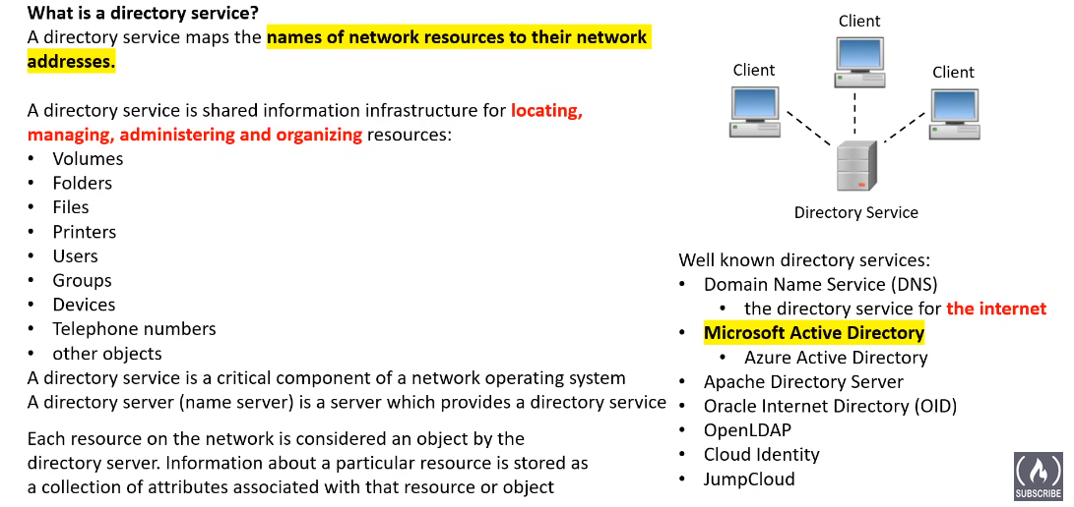

Active Directory:

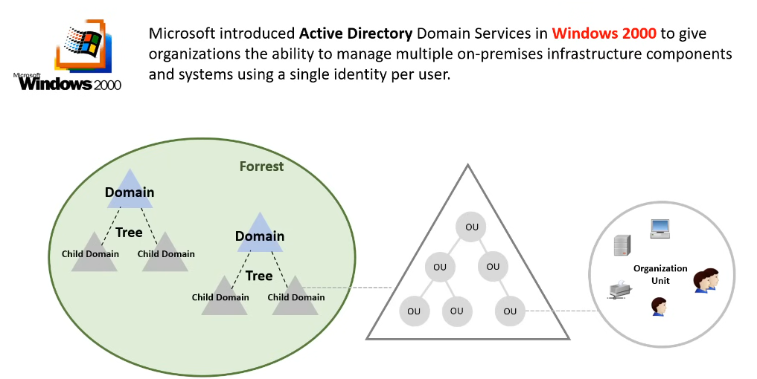

Identity Providers:

**An Identity Provider (IdP)** is a service that manages and authenticates user identities and provides information about them to other services, applications, or systems. In the context of identity and access management (IAM), an Identity Provider plays a central role in verifying the identity of users and supplying information about them to enable secure and seamless access to various resources.

Key characteristics and functions of an Identity Provider include:

* **User Authentication:** The IdP is responsible for authenticating users by verifying their identity through various means, such as passwords, multi-factor authentication (MFA), or other authentication methods.
* **User Directory:** The IdP typically maintains a user directory or database where user attributes, such as usernames, email addresses, group memberships, and other relevant information, are stored.

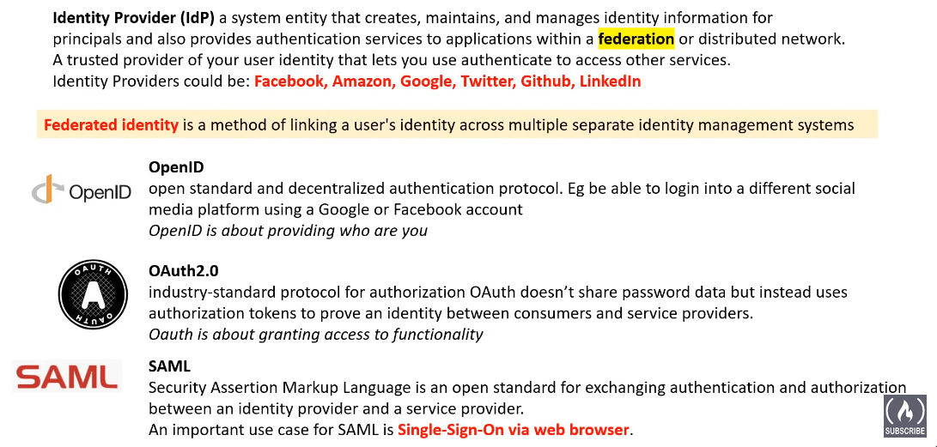

Single Sign-On:

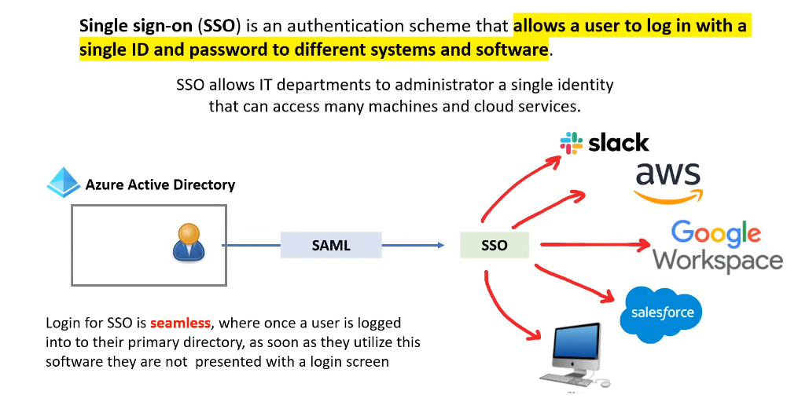

LDAP:

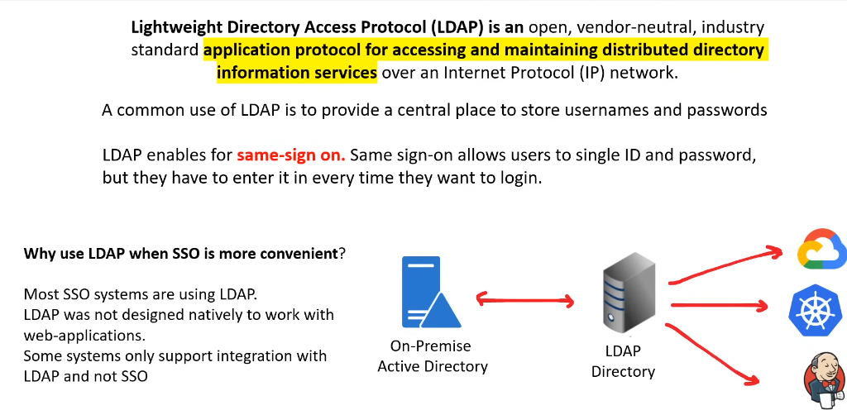

Multi Factor Authentication:

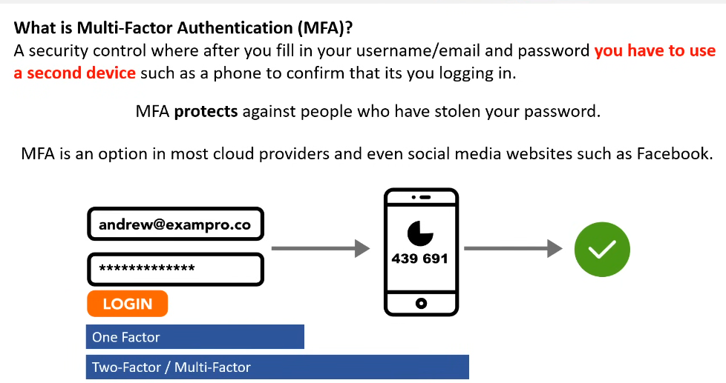

Security Keys:

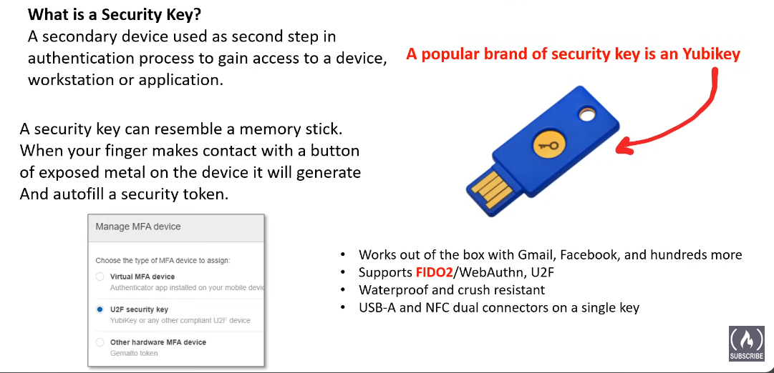

AWS IAM (Identity and Access Management):

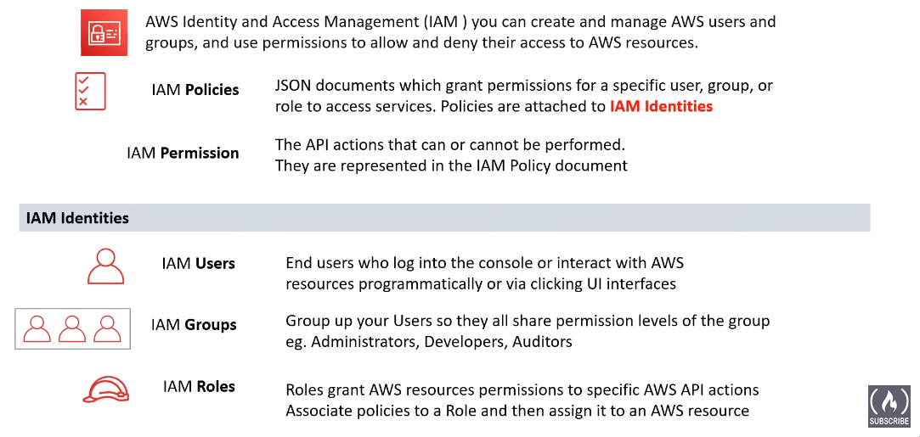

IAM roles are like magic keys for AWS resources. Users or services use these keys for specific tasks. Each key has certain powers and permissions like who can use it, Or in this context who is allowed to assume this role.

IAM roles are assumed by users, services, or AWS resources, and they have policies attached that dictate the permissions granted during the assumption of the role. Trust relationships define which entities are allowed to assume the role.

Anatomy of an IAM Policy:

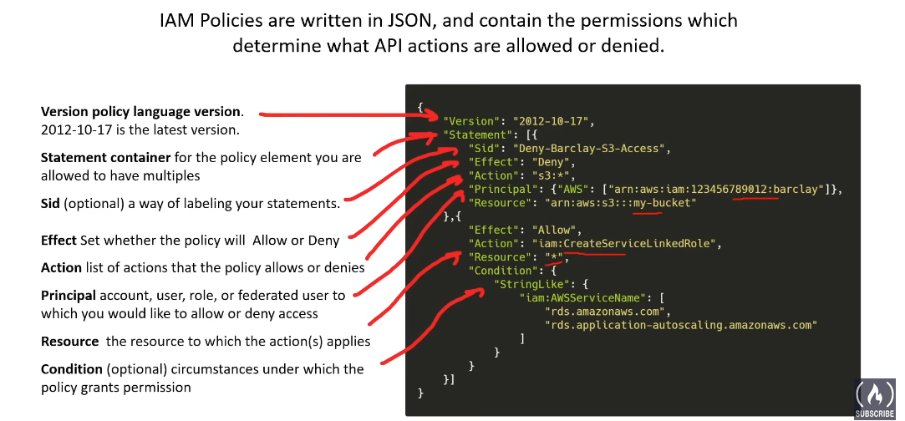

Principle of Least Privilege:

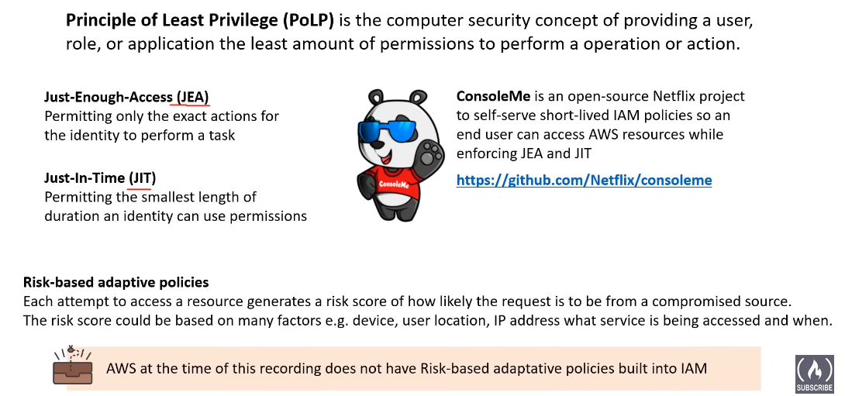

AWS Account Root User:

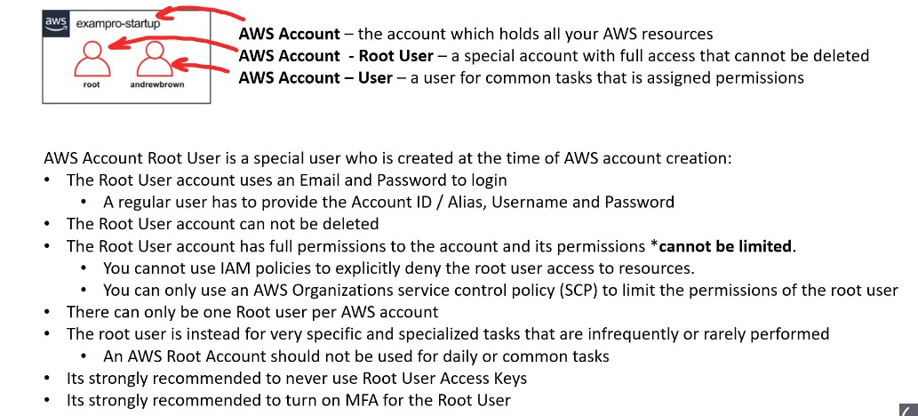

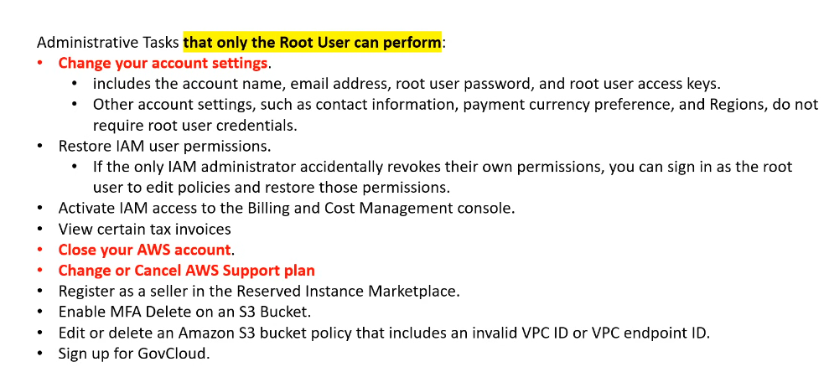

AWS SSO (Single Sign-on) or AWS IAM Identity Center:

Imagine you own a park with multiple attractions (**AWS accounts**) and your employees need access to different ones depending on their job (**permissions**). Using individual keys (logins) for each attraction would be messy and insecure.

**AWS IAM Identity Center:**

* Acts as a master keycard for your park employees.
* You create employee profiles (user identities) and link them to your directory (e.g., Active Directory).
* You assign employees to specific attractions (AWS accounts) based on their roles (e.g., gardeners to gardens, maintenance to rides).
* Each employee gets a single keycard (single sign-on) that grants access to their assigned attractions based on permissions (roles).
* You can easily add/remove employees, change their access, and track their activity, all in one place.

**Benefits:**

* Saves time and effort: No more managing individual logins for each attraction.
* Improves security: Reduces password fatigue and gives you more control over access.
* Simplified management: Easily manage employee access in one central location.

**Example:**

**Think of an employee ID badge:**

* The badge identifies the employee (IAM user).
* It might display different levels of access (IAM roles).
* Security guards (IAM policies) verify the badge and grant access to authorized areas (resources) based on the level displayed.
* Managers (administrators) can easily add/remove employees, change their access levels, and track their activity, all within a central system (**IAM Identity Center**).

It serves as a centralized hub for various identity and access management functionalities within your AWS environment.

**SSO**:

Single sign-on (SSO) is an authentication method that allows users to securely access multiple applications and websites using just one set of credentials (username and password). With SSO, instead of needing to log in separately for each application, users only need to log in once to a central service, and then they are automatically granted access to all the applications they are authorized for, without needing to re-enter their credentials.

Here's how it typically works:

**1. User logs in to the SSO portal:** The user enters their username and password once on a central platform called an SSO portal.

**2. Authentication and authorization:** The SSO portal verifies the user's credentials and checks which applications they are authorized to access.

**3. Access granted:** If the user's credentials are valid and their access is authorized, the SSO portal sends a secure token to the requested application.

**4. Automatic login:** The application receives the token from the SSO portal and automatically logs the user in without requiring them to enter their credentials again.

**5. Simplified administration:** Makes it easier for IT administrators to manage user access and permissions across multiple applications.

AWS IAM Identity Center, like many other SSO solutions, provides a centralized platform for managing user identities and access to various applications and services, promoting security, convenience, and efficiency within your IT environment.

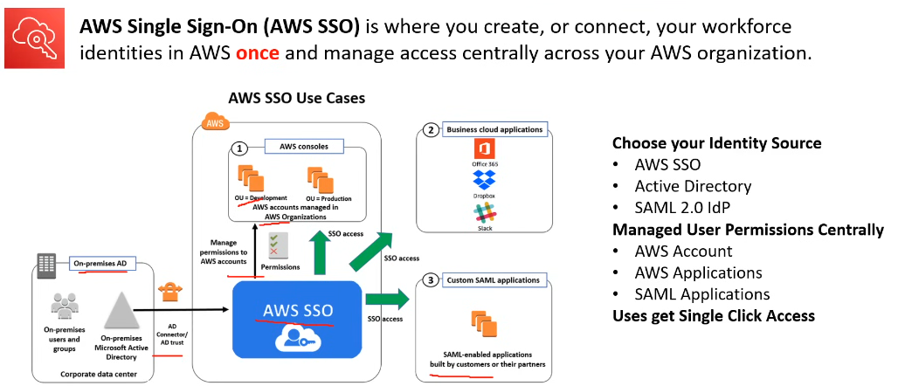

Introduction to Application Integration:

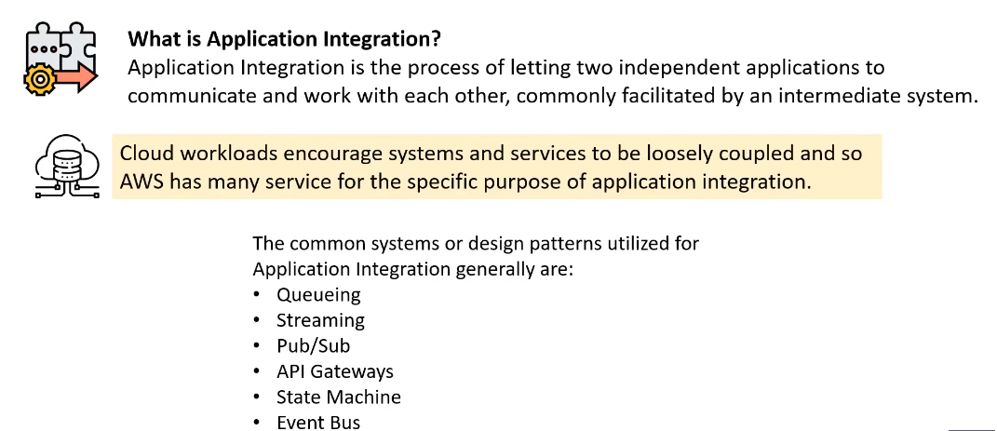

Queueing:

Amazon’s Simple Queueing Service (SQS) is a type of messaging system used for asynchronous communication between senders and receivers. Messages are added to a queue and then retrieved by receivers when they are needed. This decoupling of senders and receivers makes queuing systems a good choice for applications that need to be scalable and fault tolerant.

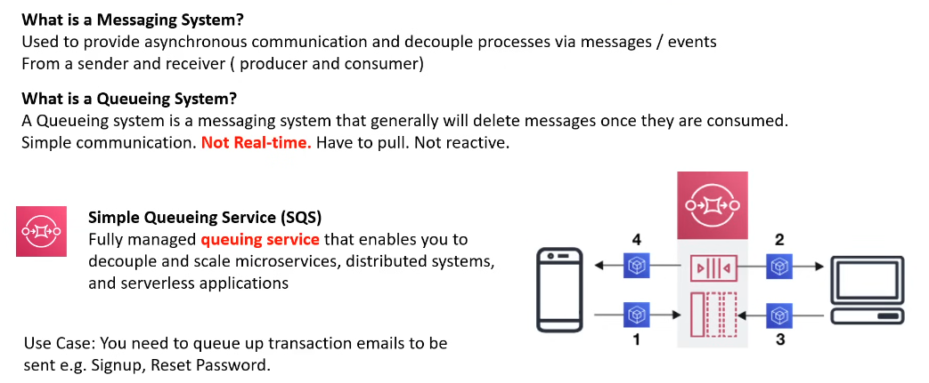

Streaming:

AWS Kinesis is a suite of services for real-time data streaming and processing. It includes:

1. Kinesis Streams:

* For ingesting and processing custom data streams in real-time.

2. Kinesis Firehose:

* Simplifies loading streaming data into AWS services without coding.

3. Kinesis Analytics:

* Allows running SQL queries on streaming data for real-time analytics.

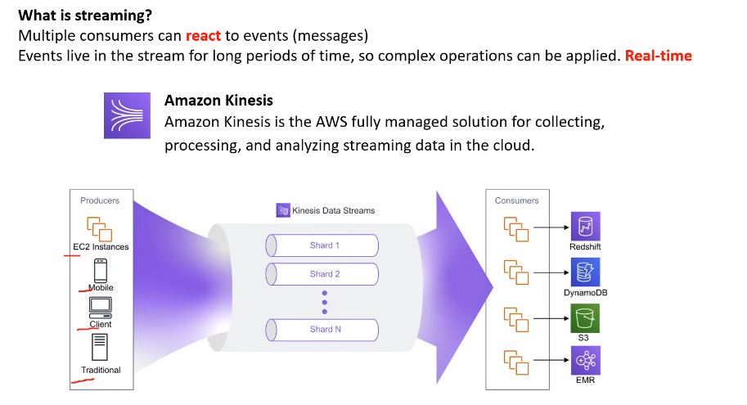

PUB-SUB and SNS:

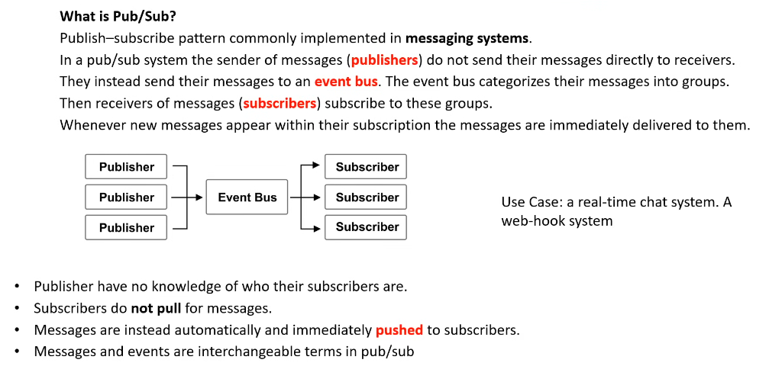

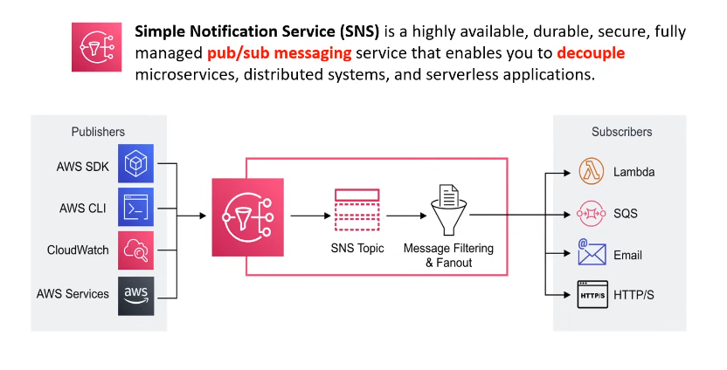

Amazon API Gateway:

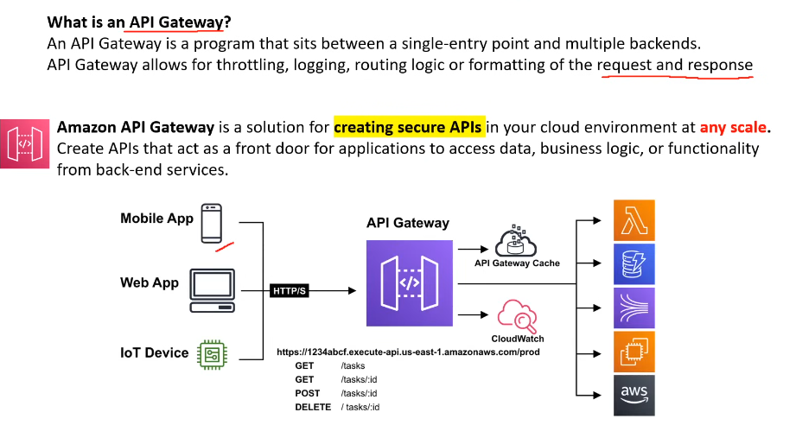

State Machine and AWS Step Function:

* Essentially like informatica workflows

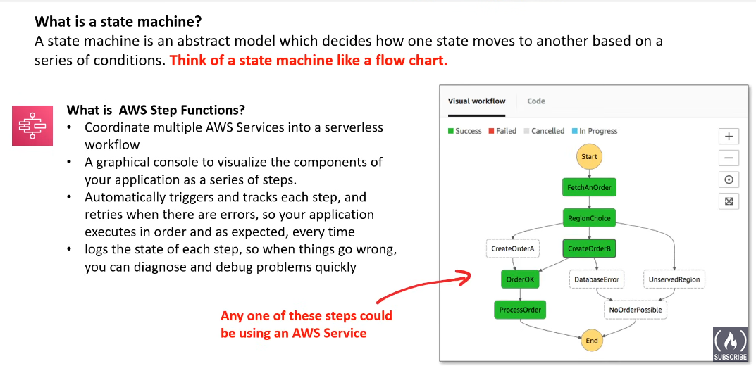

Event Bus:

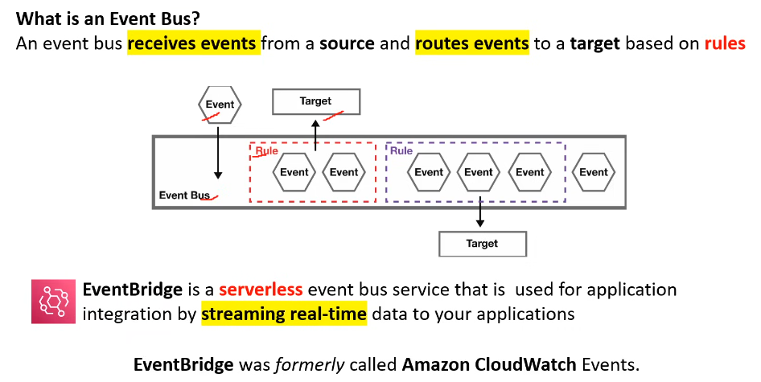

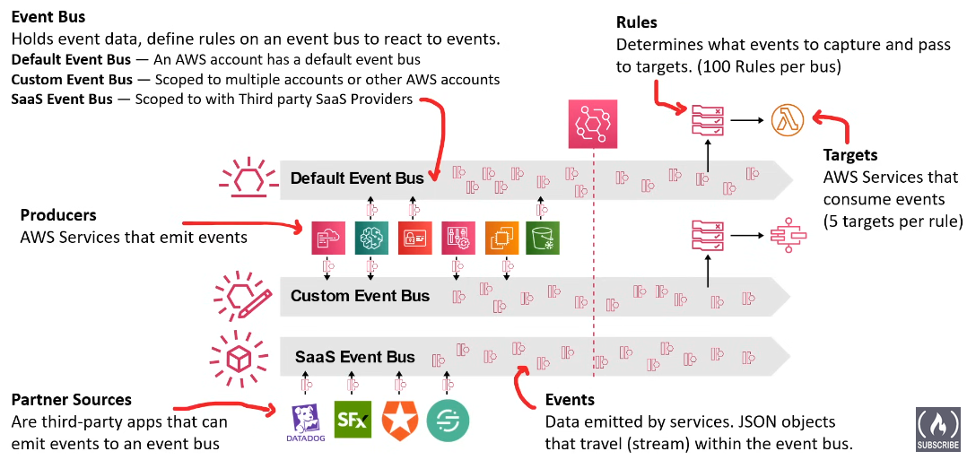

Application Integration Services:

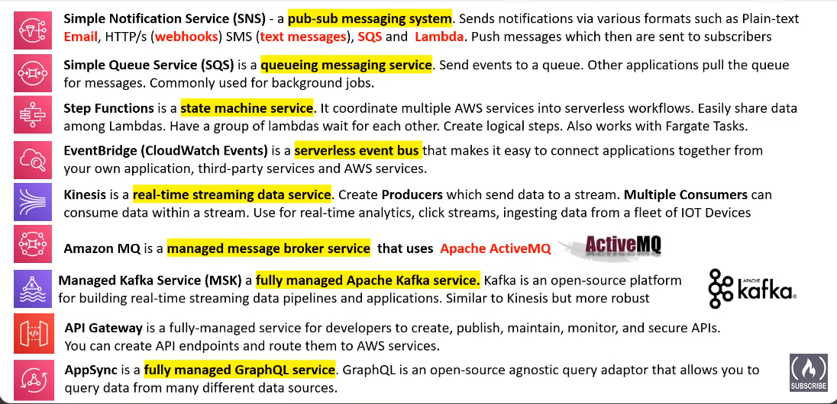

VM vs Containers:

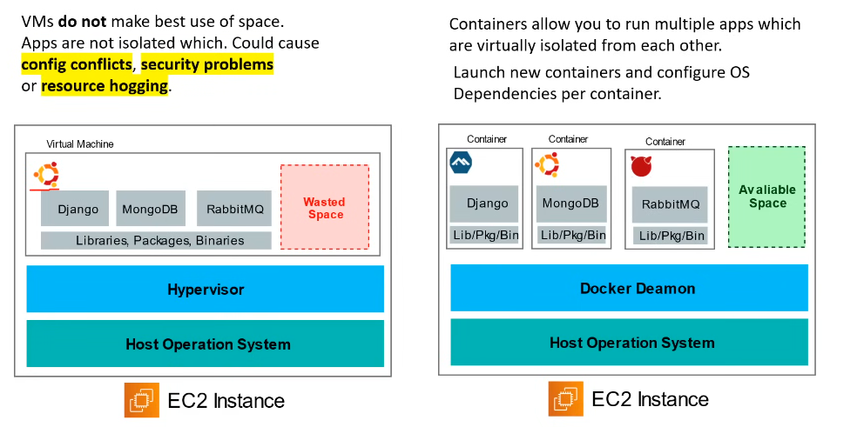

What are Microservices?

A **microservice** refers to a small, independent, and modular component of a larger application architecture that follows the microservices architectural style. The microservices architectural pattern involves breaking down a monolithic application into a set of smaller, loosely coupled services, each responsible for a specific business capability.

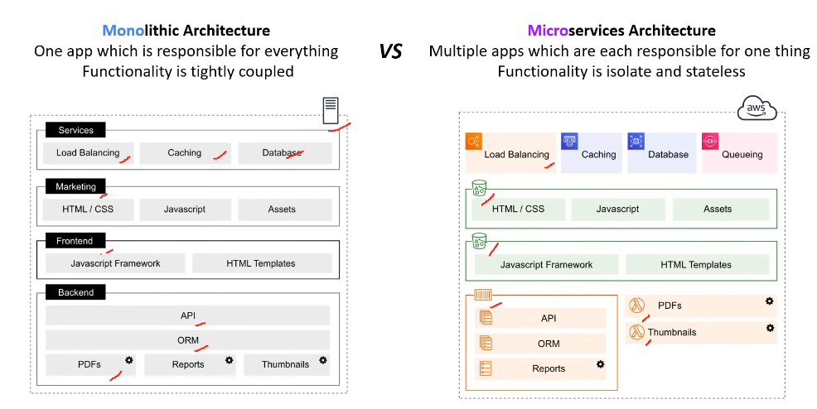

Kubernetes:

Kubernetes (sometimes referred to as K8s) is a popular open source platform that orchestrates container runtime systems across a cluster of networked resources. Kubernetes can be used with or without Docker.

Kubernetes was originally developed by Google, who needed a new way to run billions of containers a week on a scale. Kubernetes was released as open source by Google in 2014 and is now widely considered to be the market leader and industry-standard orchestration tool for containers and distributed application deployment.

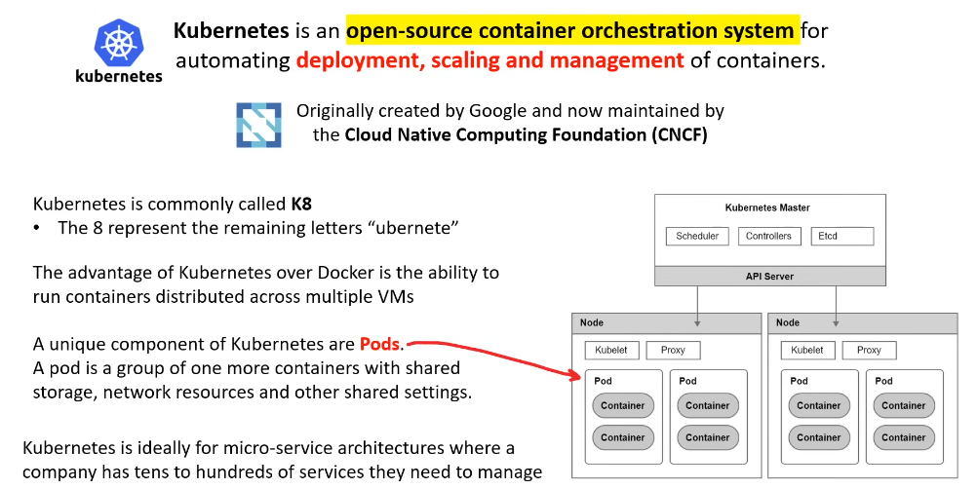

Docker:

**Docker** is a commercial containerization platform and runtime that helps developers build, deploy, and run containers. It uses a client-server architecture with simple commands and automation through a single API.

While Docker provides an efficient way to package and distribute containerized applications, running and managing containers at scale is a challenge with Docker alone. Coordinating and scheduling containers across multiple servers/clusters, upgrading or deploying applications with zero downtime, and monitoring the health of containers are just some of the considerations that need to be made.

To solve these problems and more, solutions to orchestrate containers emerged in the form of Kubernetes.

In summary, Docker helps you create and package individual containers (cookies), while Kubernetes helps you manage and orchestrate those containers (cookies) across a cluster of machines (baking tray). Together, they provide a powerful combination for developing, deploying, and managing containerized applications.

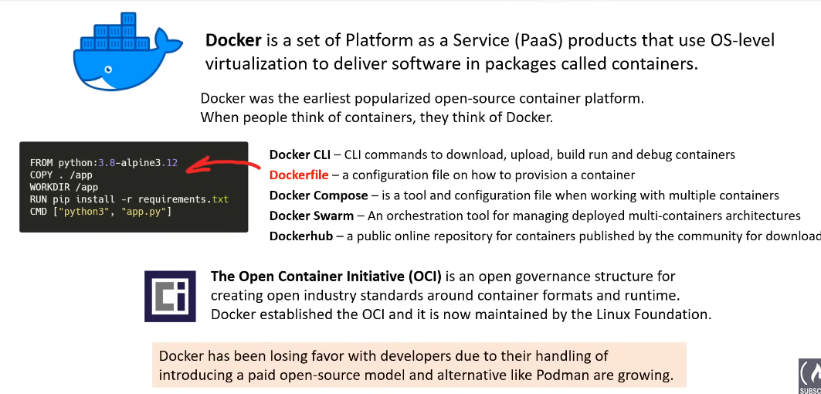

PODMAN:

